Date: | 10-04-2018 | Character count: | 1,861 | GPI: | 201810006
Tags: | Embedded, mPCIe, Wi-Fi, Bluetooth, industrial, user-friendly

Press release

User-friendly embedded PC enhancements

ADL is making their compact embedded systems more versatile by introducing practical, easy-to-use functional enhancement options for EPC-1500 series IPCs and E3800SEC single-board computers. Notably, this includes Wi-Fi and Bluetooth capabilities, which are fast becoming more and more important in Industrial IoT and SCADA applications. CAN(FD) connectivity, 4G/5G and other I/O interfaces can also be upgraded. New functions can be easily integrated using a multi-purpose carrier board that suits virtually every mPCIe module: it can either be fitted with a full-size card, or simply serve as an adapter for half-size PCBs. The board features a PCI Express lane as well an integrated USB interface, which is required to enable the dual functionality of highly sought-after Wi-Fi/Bluetooth combinations. A very solid electrical design with generously sized, stable 3.3 V and 1.8 V power supplies and excellent EMC characteristics ensures comprehensive compatibility to a wide range of mPCIe modules on the market. Other than for mPCIe users, ADL can also quickly provide solutions for customers who prefer M.2 expansion modules (2242 card format, B Key connector). The ADL enhancement concept not only gives users great flexibility. At the same time, the embedded specialists also offer short cuts by listing pre-qualified robust Wi-Fi cards and many other modules to indicate reliable long-term availability and industrial-strength quality. These select products can be operated in harsh environments at extreme temperatures from -40 to + 85 °C. Even with integrated enhanced functionality, an EPC-1500 still retains its slim dimensions of 33x86x81 mm. However, for added functions that do require more space, e.g. to accommodate extra connectors, ADL will soon launch suitable EPC-1520 housing versions with customizable, more spacious front and back panels.

Links:
Enhancements (overview): https://adl-europe.com/accessories.html
IPC ADLEPC-1500: https://adl-europe.com/products/systems/system-overwie/embedded-pc-systems-overview/adlepc-1500-mini-embedded-pc.html
IPC ADLEPC-1520: https://adl-europe.com/products/systems/system-overwie/embedded-pc-systems-overview/adlepc-1520-mini-embedded-pc.html
SBC ADLE3800SEC: https://adl-europe.com/products/embedded-sbcs/adle3800sec.html

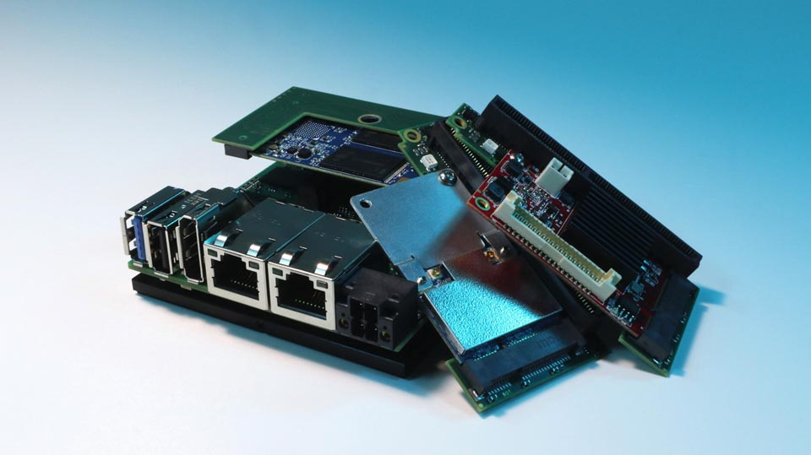
Illustration 1:
ADL now offers practical mPCIe carrier boards for EPC-1500 and E3800SEC embedded computers, enabling Wi-Fi, Bluetooth, or other I/O capabilities to be added quickly and easily

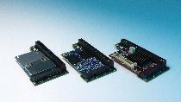 | 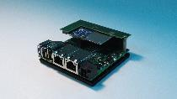
Illustration 2: | Illustration 3:
mPCIe carrier boards for ADL brand SBCs and IPCs enable functional enhancements | mPCIe carrier boards for ADL brand SBCs and IPCs enable functional enhancements

File name: | Image file name(s):
201810006_pm_expansion_opt_EPC-1500_en | SEC_mPCIe_expansion_01
 | SEC_mPCIe_expansion_02
Major topic / business unit / segment: | SEC_mPCIe_expansion_03
Embedded Computer
About ADL Embedded Solutions:
Providing a range of products from industrial single-board computers to turnkey IPC systems, ADL Embedded Solutions GmbH is able to address any customer need. Standard products as well as fully customized designs are manufactured in Germany in small, medium, or large lots as required. A German design team with over 30 years of experience stands ready to work closely with customers on their own developments, and provide any level of hands-on support they may request. All components used by ADL are not only selected for state-of-the-art performance, but most importantly for top industrial-strength quality and durability even in harsh environmental conditions. Customized cooling and housing concepts for use in confined spaces are also available. The embedded specialist relies exclusively on processors and chipsets with long-term availability and keeps an ample stock of critical components. This ensures an extended period of availability of 10 to 15 years for SBCs, enabling customers to keep deployed systems operational for more than twice the usual lifespan.
Reader contact: |  | Press contact:
ADL Embedded Solutions GmbH  Björn Laupert  Head of Technical Sales & Marketing  Eiserfelder Str. 316  57080 Siegen  Germany  Phone: +49 271 250 810-13  E-mail: bjoern.laupert@adl-europe.com  www.adl-europe.com |  | gii die Presse-Agentur GmbH  Immanuelkirchstr. 12  10405 Berlin  Germany  Phone: +49 30 538 965-0  E-mail: info@gii.de  www.gii.de

