Press Release

Fast chain hoist with continuous speed adjustment

New Star VFD electric chain hoists with load-dependent, infinitely variable speed control from 2 to 36 m/min are now available from Liftket. In some applications, even speeds up to 48 m/min are possible. Moving with no load, the hoists can be operated with up to 200 % of the nominal speed, much faster than established products. As a result, users save a lot of time. The new series is suitable for loads from 125 to 2000 kg. Liftket ships individually configured chain hoists within 15 working days. These are available with either two speed settings or with infinitely variable speed control via analog pushbuttons. In this new series, the brake engages instantly, without ramp-down. This facilitates precise positioning and also saves time compared to conventional products.

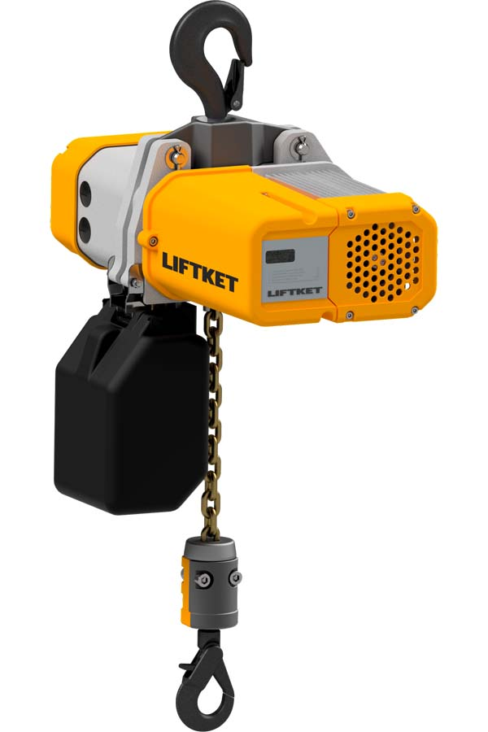
Illustration: The new electric chain hoist enables continuous speed adjustment up to 36 m/min and has a display for operating and maintenance status indicators

The Star VFD is also the first chain hoist with an integrated status display for operating hours and remaining service life. Therefore, it is not necessary to open the housing for maintenance requirement checks. Moreover, the display provides immediate information with no need to connect a computer. This decreases the maintenance effort and costs. The new speed control functionality is enabled by a frequency inverter that was designed specifically for this application. It is integrated in an electric chain hoist from the established Star series whose mechanics have been thoroughly tested and proven in hundreds of thousands of installations worldwide. The Star VFD has successfully passed the field test and is now in series production. Liftket presents this and other innovations at the LogiMAT exhibition.
Liftket at LogiMAT
Stuttgart, Germany, 19 – 21 February 2019
Hall 7, Stand A01

Illustrations: | star_vfd | Char’s: | 1592
File name: | 201901037_pm_star_vfd_variable_speed_en | Date: | 02-19-2019
About LIFTKET
LIFTKET Hoffmann GmbH is an internationally renowned manufacturer of electric chain hoists with loads ranging from 125 kg to 25,000 kg. At the company premises in Wurzen, Germany, currently about 280 employees develop and manufacture solutions for the three business segments industry, custom, and stage. A strong network of service and sales partners ensure customer-oriented stock-keeping, maintenance, and repair. LIFTKET manufactures modular electric chain hoists for virtually every application that involves the safe and precise lifting of loads. Founded in 1948 by Dietrich Hoffmann, the company initially developed agricultural equipment before specializing and exclusively focusing on electric chain hoists from 1953. Hoffmann's innovations, namely the horizontal assembly of motor and gearbox and the patented safety-brake/clutch system, still set the standard for electric chain hoists.

Reader contact:  LIFTKET Hoffmann GmbH  Dresdener Str. 64 – 68  04808 Wurzen  Germany  Phone: +49 3425 8924-0  Email: sales@liftket.de  Web: www.liftket.de | Press contact:  gii die Presse-Agentur GmbH  Immanuelkirchstr. 12  10405 Berlin  Germany  Phone: +49 30 538 965-0  Email: info@gii.de  Web: www.gii.de  LIFTKET Hoffmann GmbH  Marketing Department  Ulrike Veit  Dresdener Str. 64 – 68  04808 Wurzen  Germany  Phone: +49 3425 8924-87  Email: ulrike.veit@liftket.de  Web: www.liftket.de

