Press Release

Speedy delivery of electric chain hoists for up to 5 tons

Liftket has added new 5-ton electric chain hoists to its Speed Line. In addition, this series now features temperature monitoring of the lifting motor by default. The manufacturer configures all electric chain hoists to order. The Speed Line models are shipped within 15 working days or less. Customers can specify the suspension type (eye or hook), girder width, as well as a push trolley or electric trolley. The Speed Line allows for lifting heights up to 20 m. It therefore covers most industrial applications. If required, Liftket furthermore builds special chain hoists. The Speed Line now comprises 11 models for loads from 125 kg to 5000 kg. Depending on the load, these hoists offer different nominal speeds up to a maximum of 10 m/min. They each have two lifting speeds. Optimized for fast custom configuration, the series is also fully tested, safe, very robust, and durable. The mechanics have proven reliable in the established Star Liftket series in hundreds of thousands of installations. The chain hoist configurator on the company website gives users an express route to their tailor-made electric chain hoist.

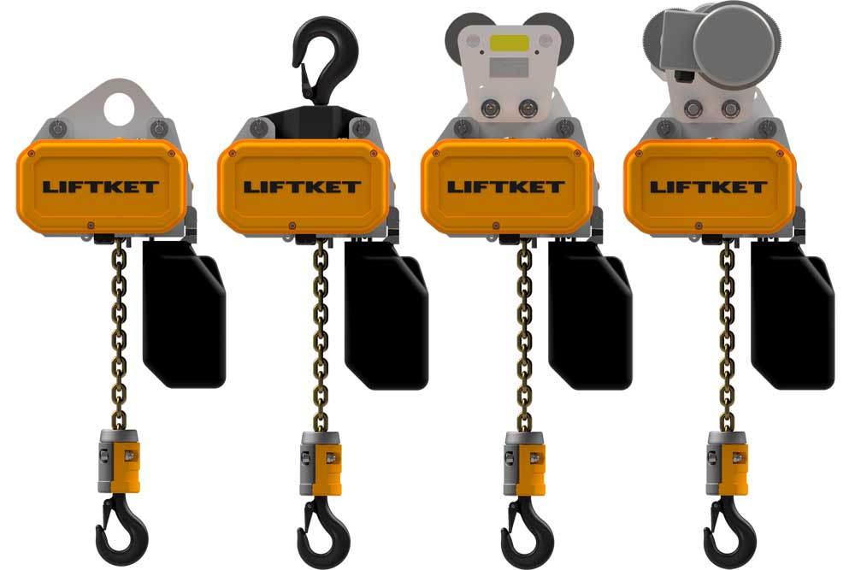
Illustration: Liftket ships tailor-made electric chain trains for loads up to 5 tons within 15 working days

Illustrations: | speed_line | Char’s: | 1127
File name: | 201902003_pm_speed_line_5t_en | Date: | 04-18-2019
About LIFTKET
LIFTKET Hoffmann GmbH is an internationally renowned manufacturer of electric chain hoists with loads ranging from 125 kg to 25,000 kg. At the company premises in Wurzen, Germany, currently about 280 employees develop and manufacture solutions for the three business segments industry, custom, and stage. A strong network of service and sales partners ensure customer-oriented stock-keeping, maintenance, and repair. LIFTKET manufactures modular electric chain hoists for virtually every application that involves the safe and precise lifting of loads. Founded in 1948 by Dietrich Hoffmann, the company initially developed agricultural equipment before specializing and exclusively focusing on electric chain hoists from 1953. Hoffmann's innovations, namely the horizontal assembly of motor and gearbox and the patented safety-brake/clutch system, still set the standard for electric chain hoists.

Reader contact:  LIFTKET Hoffmann GmbH  Dresdener Str. 64 – 68  04808 Wurzen  Germany  Phone: +49 3425 8924-0  Email: sales@liftket.de  Web: www.liftket.de | Press contact:  gii die Presse-Agentur GmbH  Immanuelkirchstr. 12  10405 Berlin  Germany  Phone: +49 30 538 965-0  Email: info@gii.de  Web: www.gii.de  LIFTKET Hoffmann GmbH  Marketing Department  Ulrike Veit  Dresdener Str. 64 – 68  04808 Wurzen  Germany  Phone: +49 3425 8924-87  Email: ulrike.veit@liftket.de  Web: www.liftket.de

