Press Release

European Coatings Show:
Monitor for perfect cure

Fluke Process Instruments presents temperature profiling technology at the 2019 European Coatings Show. The manufacturer provides dedicated hardware and software kits for monitoring thermal cure of powder-coatings, paints, adhesives, and sealants. These systems help customers ensure consistent high quality, improve efficiency, and prove compliance. The prime showcase, the recently launched Datapaq DP5 data logger provides an outstanding ±0.5 °C accuracy and ±0.1 °C resolution over the full measuring and operating temperature ranges. These loggers are available in various 6-channel and 12-channel formats with matching thermal barriers to suit any thermal process. Measurements can be started and stopped manually, via two color-coded buttons, or triggered by time or temperature. The loggers combine ease of use with excellent availability and minimal running costs: they feature a user-replaceable NimH battery pack, which can be recharged from any USB outlet or port. One 90-minute charge allows for more than 40 hours of profiling. One logger can survey up to 10 ovens in succession, storing individual profiles with up to 600k data points in total. The Datapaq Insight software quickly transforms the raw data into actionable information. It includes the Easy Oven Setup recipe calculator, SPC, and trending analysis. The portfolio is completed by various thermocouple types for all application needs. The team will be happy to advise trade-show visitors on the optimal monitoring system selection.
Fluke Process Instruments at European Coatings Show
Nuremberg, Germany, 19 – 21 March 2019
Hall 5, Stand 152
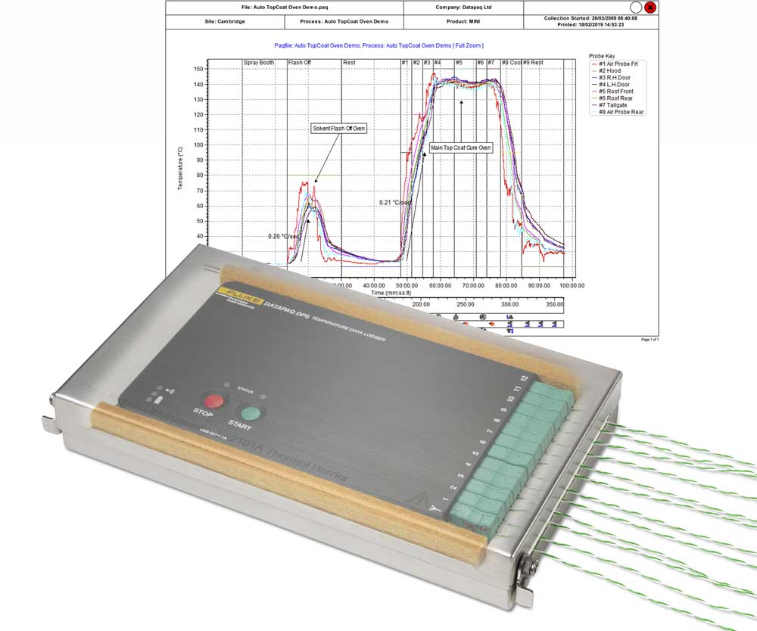
Illustration: New easy-to-use temperature profilers tailored to coating cure processes help ensure consistent high quality, improve efficiency, and prove compliance

Illustrations: | datapaq_dp5_coating | Char.s: | 1509
File name: | 201902014_pm_european_coatings_show_en | Date: | 02-27-2019
About Fluke Process Instruments
Fluke Process Instruments designs, manufactures, and markets a complete line of infrared temperature measurement and profiling solutions for industrial, maintenance, and quality control applications. Distributed worldwide under the Raytek, Ircon, and Datapaq brands, the products reflect the combined experience of over 125 years in manufacturing the world’s finest temperature measurement tools and devices.
About Fluke
Founded in 1948, Fluke Corporation is the world leader in compact, professional electronic test tools. Fluke customers are technicians, engineers, electricians, and metrologists who install, troubleshoot, and manage industrial, electrical, and electronic equipment and calibration processes.

Contact:  Fluke Process Instruments GmbH  Sabrina Balkow  Blankenburger Str. 135  13127 Berlin  Germany  Phone: +49 . 30 . 478 008-0  Email: marcom1.emea@flukeprocessinstruments.de  Internet: www.flukeprocessinstruments.com  Contact for Americas and Australasia:  Lindsay Schutter  lindsay.schutter@fluke.com  Contact for Asia (except China):  Jay Jutla  jay.Jutla@fluke.com  Contact for China:  Grace Cheng  chen.cheng@fluke.com | gii die Presse-Agentur GmbH  Immanuelkirchstr. 12  10405 Berlin  Germany  Phone: +49 . 30 . 538 965-0  Email: info@gii.de  Internet: www.gii.de

