Press Release

SMTconnect trade fair:
Precise, repeatable temperature profiling

At the 2019 SMTconnect, Fluke Process Instruments will present its new Datapaq DP5 data loggers for inline temperature profiling in reflow soldering processes. Launched at last year’s show, the profilers are now in serial production. They are showcased along with a comprehensive array of system components building on the established Datapaq Reflow Tracker program, which also comprises a dedicated software suite. These components include compact stainless-steel thermal barriers, thermocouples, and two sensor holding frames. These frames with fixed thermocouples save setup time and ensure high repeatability in monitoring process stability. The Datapaq Surveyor frame is designed to measure process performance at the critical board level. Together with the Insight Professional software, this tool detects trends in oven performance, allowing operators to take corrective action early on. The second sensor frame is a 12-thermocouple pallet for monitoring wave soldering process stability. The pre-heat, chip wave, and wave soldering phases can all be analyzed with one tool and one software. Analysis functions include maximum temperature, maximum slopes, contact time, and line speed. Users do not even have to wait for the profiler to exit the oven to visualize and analyze the data. An integrated radio transmitter optionally provides real-time data from within the process. All process and system data can also be communicated to factory-monitoring systems via the OPC interface.
Fluke Process Instruments at SMTconnect
Nuremberg, Germany, 7 – 9 May 2019
Hall 4, Stand 118

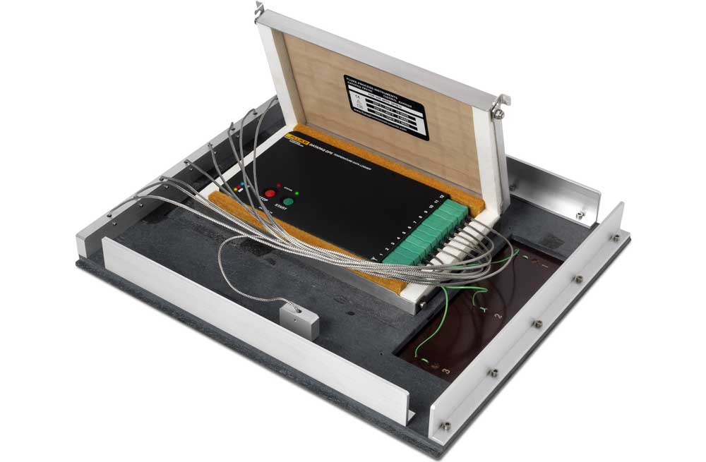
Illustration: The temperature profilers are used to monitor PCB temperatures and oven performance – via sensor fixtures like this one

Illustrations: | dp5_wave_pallete | Char.s: | 1490
File name: | 201902015_pm_smtconnect_e | Date: | 03-13-2019
About Fluke Process Instruments
Fluke Process Instruments designs, manufactures, and markets a complete line of infrared temperature measurement and profiling solutions for industrial, maintenance, and quality control applications. Distributed worldwide under the Raytek, Ircon, and Datapaq brands, the products reflect the combined experience of over 125 years in manufacturing the world’s finest temperature measurement tools and devices.
About Fluke
Founded in 1948, Fluke Corporation is the world leader in compact, professional electronic test tools. Fluke customers are technicians, engineers, electricians, and metrologists who install, troubleshoot, and manage industrial, electrical, and electronic equipment and calibration processes.

Contact:  Fluke Process Instruments GmbH  Sabrina Balkow  Blankenburger Str. 135  13127 Berlin  Germany  Phone: +49 . 30 . 478 008-0  Email: marcom1.emea@flukeprocessinstruments.de  Internet: www.flukeprocessinstruments.com  Contact for Americas and Australasia:  Lindsay Schutter  lindsay.schutter@fluke.com  Contact for Asia (except China):  Jay Jutla  jay.jutla@fluke.com  Contact for China:  Grace Cheng  chen.cheng@fluke.com | gii die Presse-Agentur GmbH  Immanuelkirchstr. 12  10405 Berlin  Germany  Phone: +49 . 30 . 538 965-0  Email: info@gii.de  Internet: www.gii.de

