Press Release

Temperature monitoring for metals and steel

Fluke Process Instruments presents its range of thermal profilers and infrared temperature measurement solutions at the THERMPROCESS trade fair. The latest addition to the IR pyrometer portfolio, Thermalert 4.0, enables automatic noncontact temperature monitoring in a -40…2250 °C range. Due to the outstanding ambient temperature range of -20…85 °C, more measuring points can be set up without cooling. Another IR innovation, the industrial-grade thermal imager ThermoView TV40 with an integrated visible-light camera, is also on show. The fixed-installation thermal camera enables 24/7 temperature monitoring in a -10…1200 °C range. Developed to meet today’s demanding industrial automation requirements, it supports GigE streaming of images and automatic alarms.

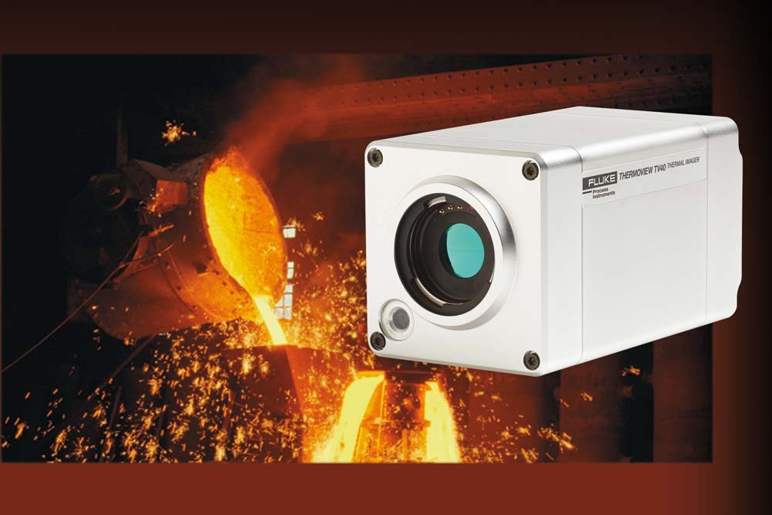
Illustration: The thermal imager enables 24/7 process monitoring with automatic alarms for overheating or defined irregularities

The manufacturer’s thermal profiling systems are represented by Datapaq TP3 data loggers, featuring up to 20 thermocouple channels and outstanding 3.6 million data points memory capacity. The loggers enable temperature uniformity surveys (TUS) and in-process product temperature monitoring. Even water or gas quench processes can be profiled. Users can easily customize reports and generate CQI-9, AMS 2750E, and ISO9000-compliant reports. The measured temperature range is -100…1370 °C with a ±0.3 °C accuracy. Fluke Process Instruments offers complete application-tailored system solutions including resilient thermal barriers, Datapaq Insight analysis software, and thermocouples. The team will be happy to advise visitors on the best way to tackle their particular application.
THERMPROCESS is part of “The Bright World of Metals”, the major international event for the metals industry, also comprising the GIFA trade fair for foundry technology, the METEC metallurgy and steel industry trade fair, and the Newcast trade fair for precision castings, which are all held concurrently in Düsseldorf.
Fluke Process Instruments at THERMPROCESS
Düsseldorf, Germany, 25 – 29 June 2019
Hall 9, Stand C73

Illustrations: | thermoview_tv40_iron_foundry_ladle | Char.s: | 1864
File name: | 201903023_pm_thermprocess_en | Date: | 04-10-2019
About Fluke Process Instruments
Fluke Process Instruments designs, manufactures, and markets a complete line of infrared temperature measurement and profiling solutions for industrial, maintenance, and quality control applications. Distributed worldwide under the Raytek, Ircon, and Datapaq brands, the products reflect the combined experience of over 125 years in manufacturing the world’s finest temperature measurement tools and devices.
About Fluke
Founded in 1948, Fluke Corporation is the world leader in compact, professional electronic test tools. Fluke customers are technicians, engineers, electricians, and metrologists who install, troubleshoot, and manage industrial, electrical, and electronic equipment and calibration processes.

Contact:  Fluke Process Instruments GmbH  Sabrina Balkow  Blankenburger Str. 135  13127 Berlin  Germany  Phone: +49 . 30 . 478 008-0  Email: marcom2.emea@flukeprocessinstruments.de  Internet: www.flukeprocessinstruments.com  Contact for Americas and Australasia:  Lindsay Schutter  lindsay.schutter@fluke.com  Contact for Asia (except China):  Jay Jutla  jay.jutla@fluke.com  Contact for China:  Grace Cheng  chen.cheng@fluke.com | gii die Presse-Agentur GmbH  Immanuelkirchstr. 12  10405 Berlin  Germany  Phone: +49 . 30 . 538 965-0  Email: info@gii.de  Internet: www.gii.de

