Press Release

SVTM trade show:
Temperature profiling in vacuum processes

At the SVTM vacuum technologies and materials treatment exhibition, Fluke Process Instruments presents powerful temperature profiling systems based on robust Datapaq TP3 data loggers. Featuring up to 20 thermocouple channels and an outstanding 3.6 million data points memory, the loggers perform up to 10 consecutive measurement runs. The systems are application-tailored for all kinds of heat treatment processes in primary and secondary metals production, including vacuum brazing, aluminum solution reheat, and water or gas quenching. The measured temperature range is -100…1370 °C with a ±0.3 °C accuracy. Datapaq TP3 data loggers can be pre-configured for mixed thermocouple types. They enable temperature uniformity surveys (TUS) and in-process product temperature monitoring. The Datapaq Insight analysis software includes comprehensive reporting functions. Users can easily customize reports and generate CQI-9, AMS 2750E, and ISO9000-compliant reports. Application-specific thermal barriers protect the electronics throughout the length of the process. The line-up includes, among others, special barriers for vacuum brazing furnaces with minimized out-gassing and low-height quench systems. The team will be happy to advise trade show visitors on the best way to tackle their particular application.
Fluke Process Instruments at SVTM
Lille, France, 3 – 4 July 2019
Stand 96

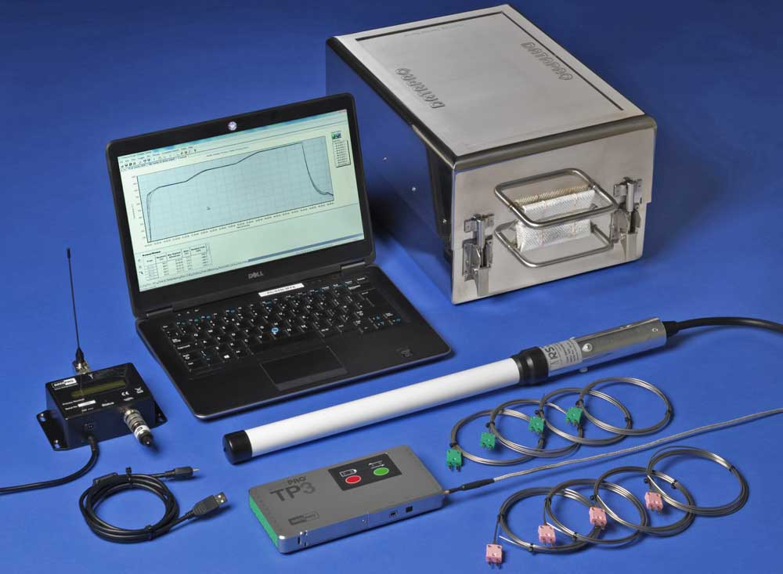
Illustration: Fluke Process Instruments provides application-specific thermal profilers consisting of a data logger, thermal barrier, thermocouples, and Datapaq Insight analysis software

Illustrations: | datapaq_tp3_system | Char.s: | 1309
File name: | 201905018_pm_datapaq_tp3_svtm_en | Date: | 06-05-2019
About Fluke Process Instruments
Fluke Process Instruments designs, manufactures, and markets a complete line of infrared temperature measurement and profiling solutions for industrial, maintenance, and quality control applications. Distributed worldwide under the Raytek, Ircon, and Datapaq brands, the products reflect the combined experience of over 125 years in manufacturing the world’s finest temperature measurement tools and devices.
About Fluke
Founded in 1948, Fluke Corporation is the world leader in compact, professional electronic test tools. Fluke customers are technicians, engineers, electricians, and metrologists who install, troubleshoot, and manage industrial, electrical, and electronic equipment and calibration processes.

Contact:  Fluke Process Instruments GmbH  Sabrina Balkow  Blankenburger Str. 135  13127 Berlin  Germany  Phone: +49 . 30 . 478 008-0  Email: marcom1.emea@flukeprocessinstruments.de  Internet: www.flukeprocessinstruments.com  Contact for Americas and Australasia:  Lindsay Schutter  lindsay.schutter@fluke.com  Contact for Asia (except China):  Jay Jutla  jay.jutla@fluke.com  Contact for China:  Grace Cheng  chen.cheng@fluke.com | gii die Presse-Agentur GmbH  Immanuelkirchstr. 12  10405 Berlin  Germany  Phone: +49 . 30 . 538 965-0  Email: info@gii.de  Internet: www.gii.de

