Press Release

SPS 2019: IR cameras and pyrometers for factory automation

Fluke Process Instruments will present infrared measurement technology for automatic, noncontact temperature monitoring in industrial processes at the SPS trade show in Nuremberg, Germany, at booth 7a-350. The sensors and thermal imagers provide outstanding robustness, precision, and connectivity. The manufacturer is expanding the Thermalert 4.0 spot pyrometer series, adding new models and interface options that will premiere at the SPS. Including the brand-new shortwave pyrometers for high-temperature applications and especially for metals and steel, the series comprises 18 models that measure temperatures ranging from -40 °C to 2300 °C. In addition to analog and RS485 interfaces, there are now also Ethernet, EtherNet/IP, and PROFINET IO interface options. The Ethernet versions can be supplied with voltage via Power over Ethernet (PoE). Another highlighted showcase, the ThermoView TV40 thermal camera incorporates an integrated visible-light camera. This industrial-grade thermal imager (IP67) is designed for fixed installation and 24/7 temperature monitoring in the -10 °C to 1200 °C range. Users can define various areas of interest with distinct alarm conditions to ensure product quality, efficient fuel use, and proper functioning of machines and equipment.
Fluke Process Instruments at SPS
Nuremberg, Germany, 26 – 28 November 2019
Hall 7a, Stand 350

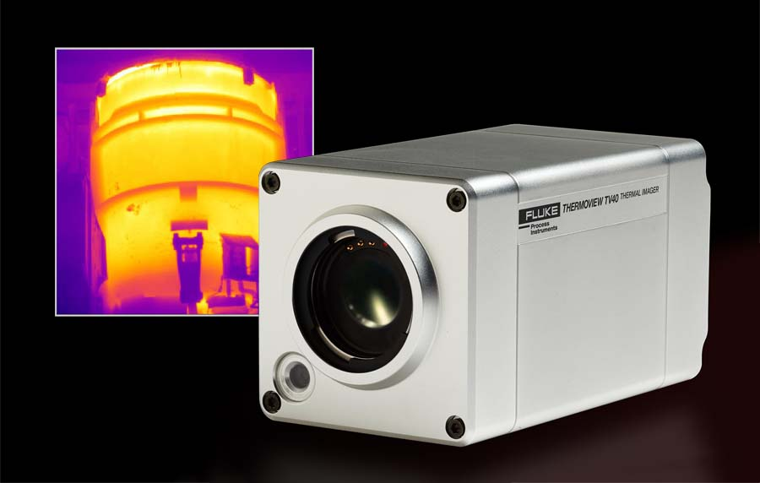
Caption: Robust thermal imaging systems enable 24/7 monitoring of belt processes as well as other industrial processes and equipment

Image/s: | thermoview_tv40_dark | Characters: | 1277
File name: | 201910023_pm_sps_trade_show_en | Date: | 10-25-2019
About Fluke Process Instruments
Fluke Process Instruments designs, manufactures, and markets a complete line of infrared temperature measurement and profiling solutions for industrial, maintenance, and quality control applications. Distributed worldwide under the Raytek, Ircon, and Datapaq brands, the products reflect the combined experience of over 125 years in manufacturing the world’s finest temperature measurement tools and devices.
About Fluke
Founded in 1948, Fluke Corporation is the world leader in compact, professional electronic test tools. Fluke customers are technicians, engineers, electricians, and metrologists who install, troubleshoot, and manage industrial, electrical, and electronic equipment and calibration processes.

Contact:  Fluke Process Instruments GmbH  Sabrina Balkow  Blankenburger Str. 135  13127 Berlin  Germany  Phone: +49 . 30 . 478 008-0  Email: marcom2.emea@flukeprocessinstruments.de  Internet: www.flukeprocessinstruments.com  Contact for Americas and Australasia:  Lindsay Schutter  lindsay.schutter@fluke.com  Contact for Asia (except China):  Jay Jutla  jay.jutla@fluke.com  Contact for China:  Grace Cheng  chen.cheng@fluke.com | gii die Presse-Agentur GmbH  Immanuelkirchstr. 12  10405 Berlin  Germany  Phone: +49 . 30 . 538 965-0  Email: info@gii.de  Internet: www.gii.de

