Press Release

Pyrometers for high temperatures and various fieldbuses

Fluke Process Instruments extends its Thermalert 4.0 spot pyrometer series, adding new shortwave versions and various additional interface options. The compact, extremely robust infrared thermometers provide noncontact, automatic temperature monitoring. Three new spectral models measuring at wavelengths of 1 µm, 1.6 µm, and 2.3 µm have been primarily designed for high-temperature applications and are particularly suitable for monitoring metal, steel, and glass. The full Thermalert 4.0 lineup covers measuring temperatures between -40 °C and 2300 °C and offers various different spectral models and focus distances. All models are now available with connectivity options for Ethernet, EtherNet/IP, and PROFINET IO, in addition to analog or RS485 interfaces. Voltage can be supplied via Power over Ethernet (PoE). The Thermalert 4.0 series features an outstanding high maximum operating temperature of 85 °C. Users can therefore save costs by setting up many measuring points without cooling. The rugged IP65 infrared thermometers exhibit best-in-class repeatabilities, response times, and accuracies. An integrated laser focus facilitates alignment. In addition, the manufacturer also offers a pyrometer without laser for particularly cost-sensitive applications. This model with an 8 µm to 14 µm spectral response has all the other advantages of the series and is suitable for a wide range of measurement tasks between -40 °C and 1000 °C.
Fluke Process Instruments at SPS
Nuremberg, Germany, 26 – 28 November 2019
Hall 7a, Stand 350

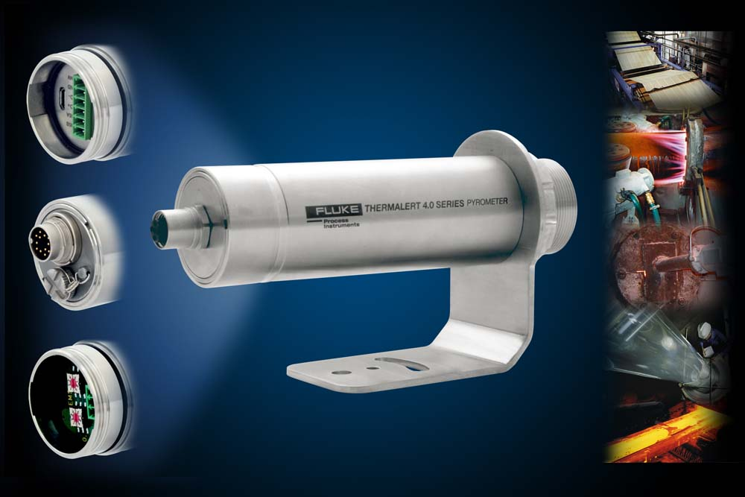
Caption: The extensive pyrometer series now offers new short-wave models and various additional interfaces

Image/s: | thermalert_40_connectivity | Characters: | 1443
File name: | 201910029_pm_thermalert_40_shortwave_en | Date: | 11-04-2019
About Fluke Process Instruments
Fluke Process Instruments designs, manufactures, and markets a complete line of infrared temperature measurement and profiling solutions for industrial, maintenance, and quality control applications. Distributed worldwide under the Raytek, Ircon, and Datapaq brands, the products reflect the combined experience of over 125 years in manufacturing the world’s finest temperature measurement tools and devices.
About Fluke
Founded in 1948, Fluke Corporation is the world leader in compact, professional electronic test tools. Fluke customers are technicians, engineers, electricians, and metrologists who install, troubleshoot, and manage industrial, electrical, and electronic equipment and calibration processes.

Contact:  Fluke Process Instruments GmbH  Sabrina Balkow  Blankenburger Str. 135  13127 Berlin  Germany  Phone: +49 . 30 . 478 008-0  Email: marcom2.emea@flukeprocessinstruments.de  Internet: www.flukeprocessinstruments.com  Contact for Americas and Australasia:  Lindsay Schutter  lindsay.schutter@fluke.com  Contact for Asia (except China):  Jay Jutla  jay.jutla@fluke.com  Contact for China:  Chen (Sam) Liu  chen.liu@fluke.com | gii die Presse-Agentur GmbH  Immanuelkirchstr. 12  10405 Berlin  Germany  Phone: +49 . 30 . 538 965-0  Email: info@gii.de  Internet: www.gii.de

