Press Release

Large-area thermal viewing

Fluke Process Instruments has launched the rugged Pan and Tilt enclosure for its ThermoView TV40 thermal imaging camera. Enabling 24/7 large-area monitoring for hot spots, cold spots, or temperature irregularities, the TV40 Pan and Tilt is a powerful critical asset monitoring tool. The enclosure for wall or pedestal mounting can rotate the camera head a full 360° continuously and tilt it from -40° to 90°. It has a -40 °C to 50 °C ambient temperature range and provides IP66 ingress protection against water and dust. Applications include ensuring the functionality of electric power infrastructure and fire prevention in coal yards, grain storage, and recycling facilities. The TV40 integrates thermal and visual sighting capabilities for easy camera alignment and added detail on blended infrared and visual images. Analysis tools include image subtraction, isotherms, and histograms. Users can define an unlimited number of AOI (areas of interest) with individual conditions for automatic alarms via Modbus, digital outputs, or email. In contrast to intermittent checks with handheld thermal cameras, this system is always on the spot and unfailingly monitors areas at risk, allowing timely corrective action. The Modbus output allows for easy SCADA integration. In addition, the system also features 1-Gbit Ethernet communication with PoE capability.

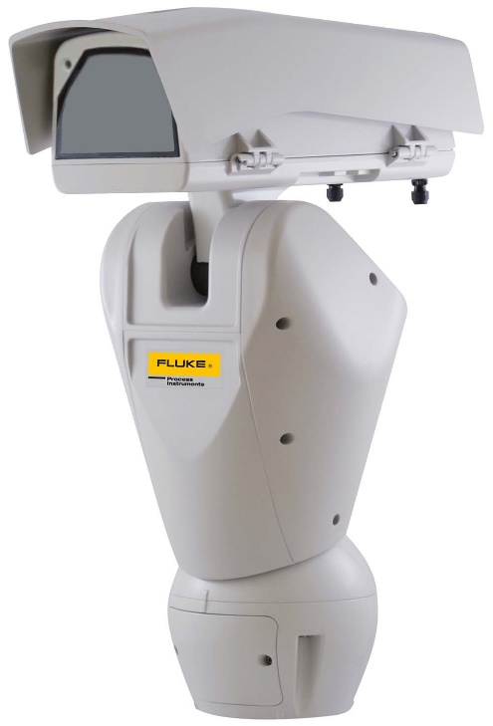
Caption: Surround vision for critical asset monitoring: the system scans large areas and enables automatic alarms, detailed analysis, and SCADA interconnection

Image/s: | Pan_and_Tilt_Housing_HR | Characters: | 1356
File name: | 202004025_pm_thermoview_tv40_pan_tilt_en | Date: | 05-13-2020
About Fluke Process Instruments
Fluke Process Instruments designs, manufactures, and markets a complete line of infrared temperature measurement and profiling solutions for industrial, maintenance, and quality control applications. Distributed worldwide under the Raytek, Ircon, and Datapaq brands, the products reflect the combined experience of over 150 years in manufacturing the world’s finest temperature measurement tools and devices.
About Fluke
Founded in 1948, Fluke Corporation is the world leader in compact, professional electronic test tools. Fluke customers are technicians, engineers, electricians, and metrologists who install, troubleshoot, and manage industrial, electrical, and electronic equipment and calibration processes.

Contact:  Fluke Process Instruments GmbH  Blankenburger Str. 135  13127 Berlin  Germany  Phone: +49 . 30 . 478 008-0  Email: marketing@flukeprocessinstruments.de  Internet: www.flukeprocessinstruments.com | gii die Presse-Agentur GmbH  Immanuelkirchstr. 12  10405 Berlin  Germany  Phone: +49 . 30 . 538 965-0  Email: info@gii.de  Internet: www.gii.de

