Press Release

To boil, or not to boil

The food processing industry relies heavily on temperature measurement – not only to prove compliance with food safety but also as a crucial means to optimize cooking cycles and save money. As a provider of thermal profiling and non-contact infrared temperature measurement solutions, Fluke Process Instruments has all requirements covered. Datapaq Food Tracker systems record the product and air temperatures in such processes as cooking, baking, and freezing. Based on a Datapaq datalogger, thermocouples, a protective barrier, and the powerful, yet easy to use Insight analysis software for lethality calculations, they pass through the process with the food products and generate HACCP-compliant reports. The Food Tracker’s radio functionality enables real-time cook validation, allowing operators to shorten cooking cycles and increase throughput. Complementing the profiling systems, infrared spot pyrometers such as the Thermalert 4.0, linescanners such as the Raytek MP150, and the TV40 thermal camera enable end-to-end product temperature monitoring. All these systems can continually monitor food products as they enter and exit an oven or chiller. They are designed for integration into process control systems and can be built into machinery for OEM applications.
More information: https://get.flukeprocessinstruments.com/foodsolutions/email/

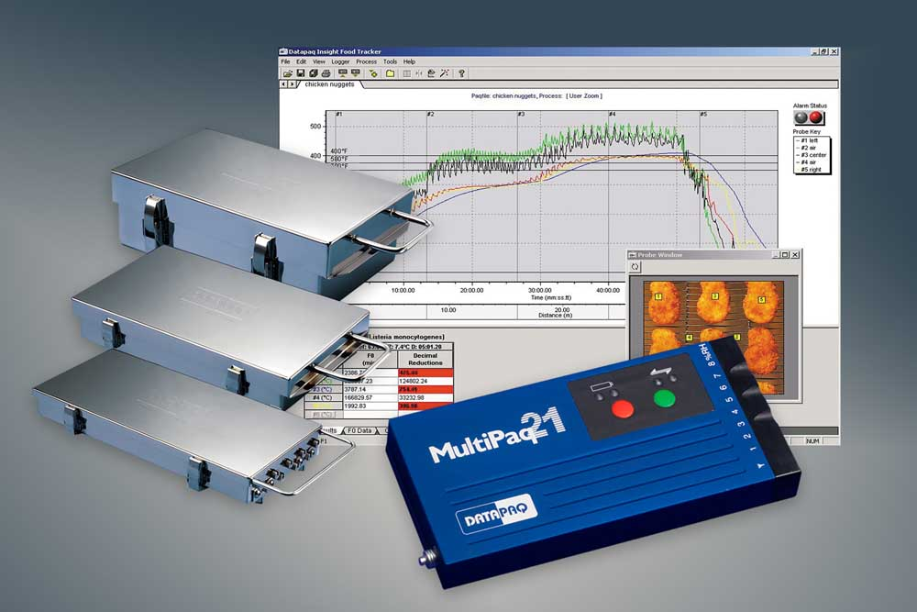
Caption 1: The measurement technologies perfectly complement one another: Datapaq Food Tracker systems record detailed product temperature profiles throughout cook and chill processes…

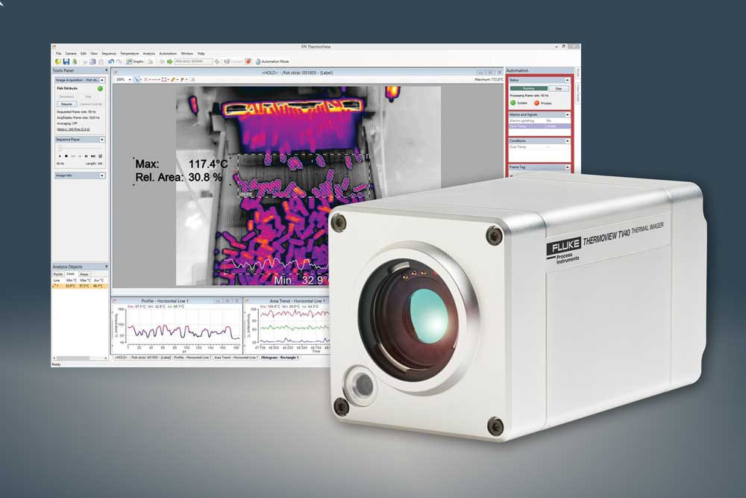
Caption 2: …and infrared monitoring equipment keeps an eye on products as they enter and leave processes

Image/s: | food_multipaq21  food_tv40 | Characters: | 1275
File name: | 202006023_pm_food_processing_temp_meas_en | Date: | 07-01-2020
About Fluke Process Instruments
Fluke Process Instruments designs, manufactures, and markets a complete line of infrared temperature measurement and profiling solutions for industrial, maintenance, and quality control applications. Distributed worldwide under the Raytek, Ircon, and Datapaq brands, the products reflect the combined experience of over 150 years in manufacturing the world’s finest temperature measurement tools and devices.
About Fluke
Founded in 1948, Fluke Corporation is the world leader in compact, professional electronic test tools. Fluke customers are technicians, engineers, electricians, and metrologists who install, troubleshoot, and manage industrial, electrical, and electronic equipment and calibration processes.

Contact:  Fluke Process Instruments GmbH  Leonardo Trame  Blankenburger Str. 135  13127 Berlin  Germany  Phone: +49 . 30 . 478 008-0  Email: marketing@flukeprocessinstruments.de  Internet: www.flukeprocessinstruments.com | gii die Presse-Agentur GmbH  Immanuelkirchstr. 12  10405 Berlin  Germany  Phone: +49 . 30 . 538 965-0  Email: info@gii.de  Internet: www.gii.de

