Press Release

High-precision, high-temperature reference pyrometers limited packaging offer

The innovative one- and two-color Endurance pyrometers from Fluke Process Instruments are ideal for use as dedicated calibration instruments (DCI). They provide top precision in low- and high-temperature applications in all kinds of industries. The measured temperature range is 50 °C to 3200 °C. The devices feature comprehensive communications and power interfaces and optional video functionality and are Industry 4.0 compliant. The manufacturer operates an independent in-house DAkkS laboratory in its Berlin plant and supplies the infrared pyrometers with a DAkkS calibration certificate with three customer-specified calibration points. The maximum deviation is only ±0.2% for single-color shortwave Endurance pyrometers and ±0.3% for two-color ratio pyrometers. Fluke Process Instruments has announced a limited offer valid until 20 November 2020, including an Endurance high-precision reference pyrometer, a DAkkS certificate, and a demo case containing mounting accessories and software. More information about this offer, the product, and its applications is available at https://get.flukeprocessinstruments.com/endurance-pyrometer-europe-limitedoffer2020/.

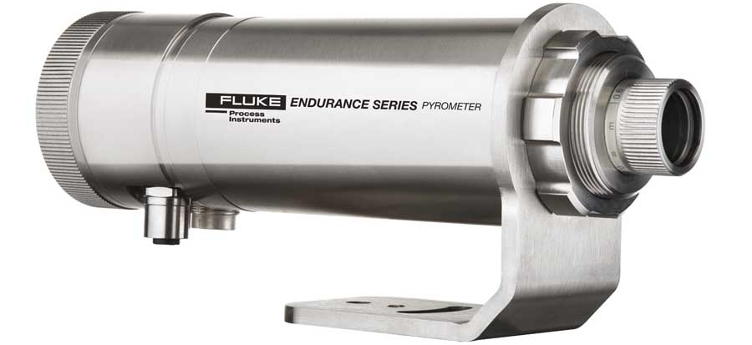
Caption: Endurance pyrometers are ideal as dedicated calibration instruments for applications demanding high precision

Image/s: | endurance_phase2_rside | Characters: | 1167
File name: | 202009028_pm_endurance_promo_en | Date: | 09-22-2020
About Fluke Process Instruments
Fluke Process Instruments designs, manufactures, and markets a complete line of infrared temperature measurement and profiling solutions for industrial, maintenance, and quality control applications. Distributed worldwide under the Raytek, Ircon, and Datapaq brands, the products reflect the combined experience of over 150 years in manufacturing the world’s finest temperature measurement tools and devices.
About Fluke
Founded in 1948, Fluke Corporation is the world leader in compact, professional electronic test tools. Fluke customers are technicians, engineers, electricians, and metrologists who install, troubleshoot, and manage industrial, electrical, and electronic equipment and calibration processes.

Contact:  Fluke Process Instruments GmbH  Leonardo Trame  Blankenburger Str. 135  13127 Berlin  Germany  Phone: +49 . 30 . 478 008-0  Email: marketing@flukeprocessinstruments.de  Internet: www.flukeprocessinstruments.com | gii die Presse-Agentur GmbH  Immanuelkirchstr. 12  10405 Berlin  Germany  Phone: +49 . 30 . 538 965-0  Email: info@gii.de  Internet: www.gii.de

