Press Release

ECHT European Conference on Heat Treatment:
Temperature monitoring and QA solutions

Fluke Process Instruments will present temperature measurement solutions and connect with customers at the ECHT 2020 web conference and expo, 30 Nov – 2 Dec. Interested parties can register at https://www.a3ts.org/echt2020/ to join the digital conference, visit the virtual booth, and arrange one-on-one audio/video chats with industry experts. Fluke Process Instruments manufactures both infrared sensors and datalogging systems. These powerful hardware and software systems provide crucial information for quality assurance, process optimization, and audits. Highlighted products at the ECHT virtual booth include the ThermoView TV40 combined thermal and visible-light camera, which is used, for instance, to check temperatures of molten metal and monitor ladles for hotspots. In contrast to thermal cameras, the Raytek MP150 infrared linescanner targets continuous processes and needs only a very narrow field of view to create a full thermal image of moving objects. Measured temperatures range up to 1200 °C for thermal imagers and 3200 °C for spot pyrometers.

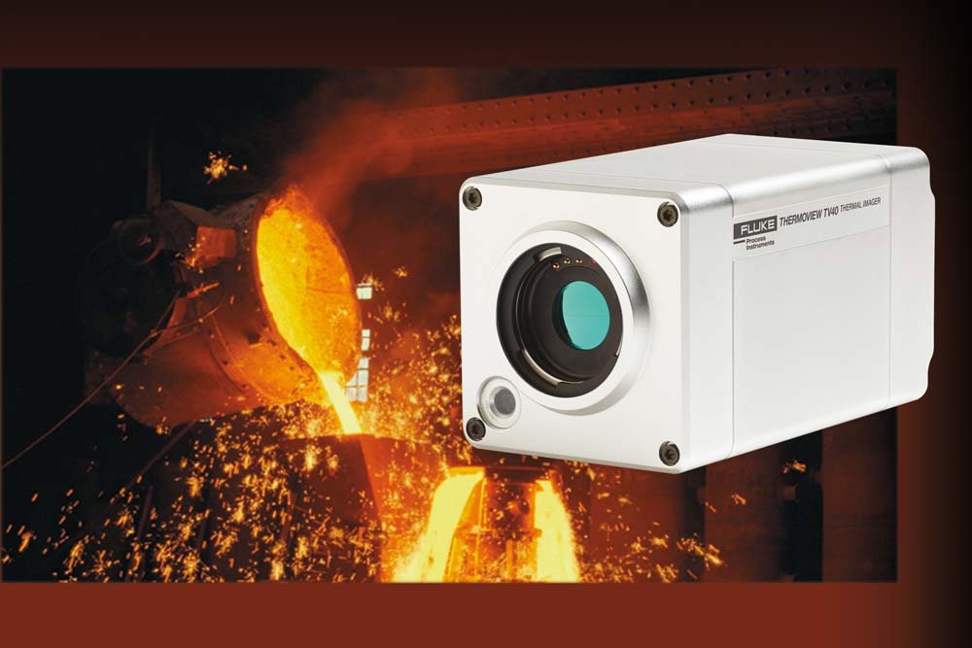
Caption: Thermal imagers detect hotspots and help operators avoid costly damage and unscheduled downtime

The latter provide targeted readings of selected areas. Via maximum value hold, they can even monitor wires. The virtual showcase includes the high-end Endurance spot pyrometer series and the Thermalert 4.0 series, geared at particularly cost-sensitive applications. Both series offer best-in-class accuracy and repeatability. Various spectral models are available, and the Endurance series comprises monochrome and ratio pyrometer models and a version with a remote sensing head for ambient temperatures up to 315 °C.
Also on show, the Datapaq Furnace Tracker performs temperature uniformity surveys (TUS) and system accuracy tests (SAT) compliant with NADCAP AMS 2750E and CQI-9. This system is based on the Datapaq TP3 data logger with up to 20 measurement channels, which travels through heat-treatment and quench processes protected by a thermal barrier. The system furthermore includes analysis and reporting software and thermocouples.

Image/s: | thermoview_tv40_iron_foundry_ladle | Characters: | 2006
File name: | 202011010_pm_echt_web_expo_en | Date: | 11-12-2020
About Fluke Process Instruments
Fluke Process Instruments designs, manufactures, and markets a complete line of infrared temperature measurement and profiling solutions for industrial, maintenance, and quality control applications. Distributed worldwide under the Raytek, Ircon, and Datapaq brands, the products reflect the combined experience of over 150 years in manufacturing the world’s finest temperature measurement tools and devices.
About Fluke
Founded in 1948, Fluke Corporation is the world leader in compact, professional electronic test tools. Fluke customers are technicians, engineers, electricians, and metrologists who install, troubleshoot, and manage industrial, electrical, and electronic equipment and calibration processes.

Contact:  Fluke Process Instruments GmbH  Leonardo Trame  Blankenburger Str. 135  13127 Berlin  Germany  Phone: +49 . 30 . 478 008-0  Email: marketing@flukeprocessinstruments.de  Internet: www.flukeprocessinstruments.com | gii die Presse-Agentur GmbH  Immanuelkirchstr. 12  10405 Berlin  Germany  Phone: +49 . 30 . 538 965-0  Email: info@gii.de  Internet: www.gii.de

