Press Release

Rugged, smart pyrometers –
ATEX/IECEx/CCC-IS certification and HART interface added

Fluke Process Instruments expands its Thermalert 4.0 pyrometer series, adding intrinsically safe models and HART protocol as an additional interface option. The rugged, intelligent and compact infrared temperature sensors in an IP65-rated stainless-steel housing are easy to connect via 2-wire installation. The series provides a future-proof, Industry-4.0-ready solution for non-contact, automatic, real-time temperature monitoring. Various spectral models cover a large measured temperature range from -40 °C to 2300 °C and all kinds of industrial applications, such as primary and secondary metals, glass and plastics manufacturing. The new intrinsically safe models rated Ex ib now add infrared thermometer options for use in hazardous environments with potentially explosive gas or dust atmospheres (zones 1 and 21). Accordingly, all models are optionally available with an ATEX/IECEx/CCC-IS certification, with the only exception of sensors with plastic lenses.

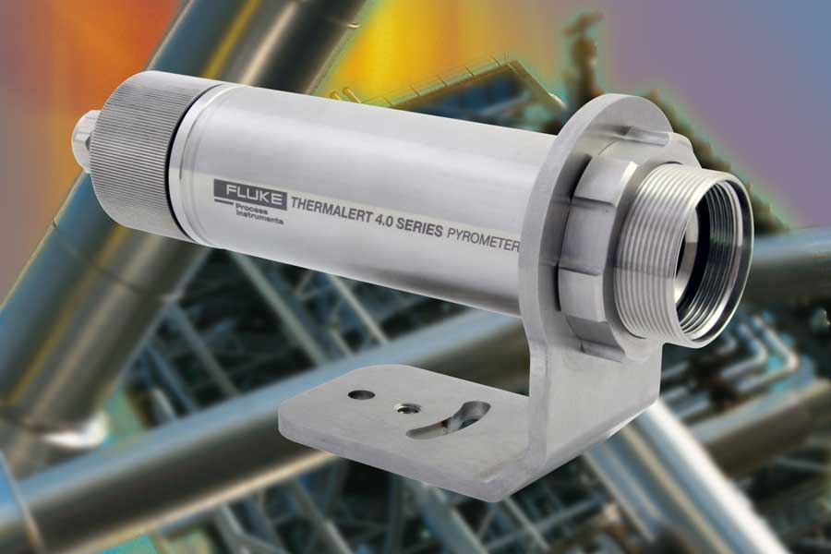
Caption: The Thermalert 4.0 series offers various IR temperature sensors for automatic process control and has now been expanded by intrinsically safe ATEX/IECEx/CCC-IS-certified options

The IR temperature sensors feature galvanically isolated analog and RS485 interfaces. Up to 32 devices can be connected within an RS485 network. All models are also available with connectivity options for Ethernet, EtherNet/IP, PROFINET IO and HART protocol as the latest addition. Voltage can be supplied via Power over Ethernet (PoE). A large choice of optics is available for long and short focal distances. The IR sensors achieve outstanding optical resolutions and provide high-precision data for efficient process control and quality assurance. The Thermalert 4.0 series features an exceptionally high maximum operating temperature of 85 °C, which allows users to save costs by setting up many measuring points without cooling. Moreover, the sensors can be read out, configured, calibrated and fitted with firmware updates remotely via the internet. This minimizes service costs per measuring point. An integrated laser focus facilitates alignment. The easy installation additionally facilitates commissioning and maintenance.

Image/s: | thermalert_40_ex | Characters: | 1999
File name: | 202107022_pm_thermalert_4-0_ex_i__hart_en | Date: | 07-15-2021
About Fluke Process Instruments
Fluke Process Instruments designs, manufactures, and markets a complete line of infrared temperature measurement and profiling solutions for industrial, maintenance, and quality control applications. Distributed worldwide under the Raytek, Ircon, and Datapaq brands, the products reflect the combined experience of over 150 years in manufacturing the world’s finest temperature measurement tools and devices.
About Fluke
Founded in 1948, Fluke Corporation is the world leader in compact, professional electronic test tools. Fluke customers are technicians, engineers, electricians, and metrologists who install, troubleshoot, and manage industrial, electrical, and electronic equipment and calibration processes.
Contact:  Fluke Process Instruments GmbH  Blankenburger Str. 135  13127 Berlin  Germany  Phone: +49 . 30 . 478 008-0  Email: marketing@flukeprocessinstruments.de  Internet: www.flukeprocessinstruments.com |  | gii die Presse-Agentur GmbH  Immanuelkirchstr. 12  10405 Berlin  Germany  Phone: +49 . 30 . 538 965-0  Email: info@gii.de  Internet: www.gii.de

