Press Release

Fluke Process Instruments Debuts New Datapaq® Furnace Tracking Systems for Demanding Heat Treat Applications
The new thermal profiling solutions feature new sealed quench thermal barriers and IP67 rated data logger

Fluke Process Instruments, a global leader in infrared imaging and thermal profiling solutions for industrial applications, releases the latest Datapaq® Furnace Tracker System – complete with the TP6 data logger, thermal barriers and intuitive software.
The Datapaq Furnace Tracker System is designed to be used repeatedly, in-process in the most hostile manufacturing environments, providing accurate and reliable through-process temperature surveys. Each system can help users improve process performance, decrease downtime, reduce temperature uniformity survey (TUS) reporting times and more.

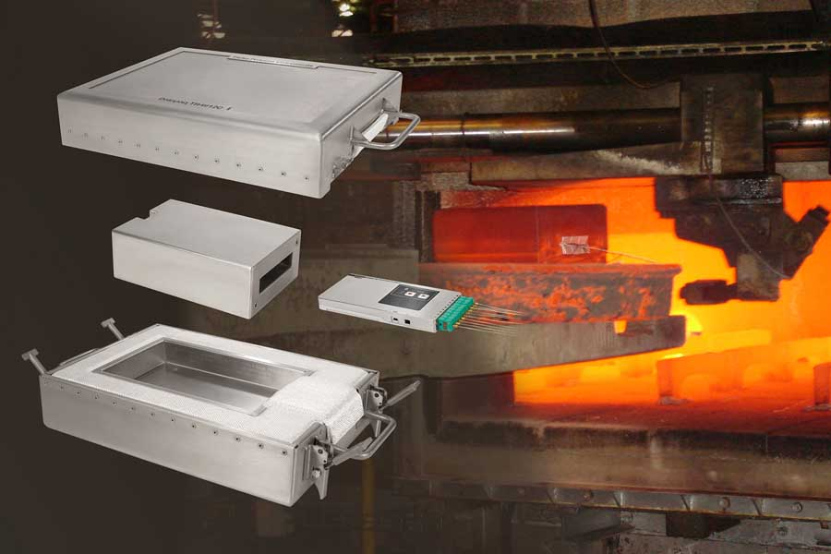
Caption: The new Datapaq Furnace Tracker systems capture temperature profiles inside the longest heat treatment processes and during quenching

The first component of the system is the Datapaq® TP6 Data Logger, which can withstand the longest, most-demanding operating conditions. The Datapaq TP6 features a 316-grade, stainless-steel case and a IP67 rating, making it water-resistant. This datalogger is available with either 10 or 20 thermocouple inputs and can be specified for use with base or noble metal thermocouples.
The latest thermal barrier models are ideal for high-temperature heat treat processes and have been designed to provide maximum thermal protection – including applications such as vacuum and controlled atmosphere, slab reheat and solution aging, among others. The new patented quenchable thermal barriers eliminate the need for fiber blankets. Fluke Process Instruments also offers bespoke design services to create a solution that specifically fits a customer’s process.
To complete the system, Fluke Process Instruments offers the Datapaq Insight™ Software, which transforms raw data into actionable analytics and features a clear user interface, context-sensitive help screens and assistance options for infrequent users. Three software options are available, and the complimentary Datapaq Insight for mobile is offered for free. This mobile application allows users to reset, download and analyze right on the factory floor and check thermocouple operation before a thermal profile run. The advanced TUS software also provides full temperature profiles and traceable reports for industry regulations like AMS2750 and CQI-9.
“The latest Datapaq Furnace Tracker System offers customers a robust solution that is designed for harsh environments like quenching and high temperatures,” says Rob Hornsblow, Product Manager at Fluke Process Instruments. “Whether users are working with raw materials or finished products, measuring product and atmosphere temperatures throughout the furnace is critical in ensuring both product quality and process efficiency. Datapaq continues to provide real-time, repeatable temperature data that can help improve performance and system accuracy, decrease downtime and much more.”
“We’ve really focused on what customers wanted when engineering this new system, and we are excited to introduce the patented quenchable thermal barriers, an IP67-rated data logger and the Insight for Mobile application that will allow users to check thermocouple operation before each run.”
The Datapaq Furnace Tracker Systems – including the new TP6 Data Logger and thermal barrier models – are now available. To learn more, or to speak with a specialist in your region, visit https://lp.flukeprocessinstruments.com/datapaq-thermal-profiling-solutions/pr/.

Image/s: | datapaq_furnace_tracker_tp6 | Characters: | 3242
File name: | 202108006_pm_datapaq_furnace_tracker_tp6_en | Date: | 09-13-2021
About Fluke Process Instruments
Fluke Process Instruments designs, manufactures, and markets a complete line of infrared temperature measurement and profiling solutions for industrial, maintenance, and quality control applications. Distributed worldwide under the Raytek, Ircon, and Datapaq brands, the products reflect the combined experience of over 150 years in manufacturing the world’s finest temperature measurement tools and devices.
About Fluke
Founded in 1948, Fluke Corporation is the world leader in compact, professional electronic test tools. Fluke customers are technicians, engineers, electricians, and metrologists who install, troubleshoot, and manage industrial, electrical, and electronic equipment and calibration processes.
Contact:  Fluke Process Instruments GmbH  Blankenburger Str. 135  13127 Berlin  Germany  Phone: +49 . 30 . 478 008-0  Email: marketing@flukeprocessinstruments.de  Internet: www.flukeprocessinstruments.com |  | gii die Presse-Agentur GmbH  Immanuelkirchstr. 12  10405 Berlin  Germany  Phone: +49 . 30 . 538 965-0  Email: info@gii.de  Internet: www.gii.de

