Press release

The smallest LVDT with probe function in the world – from Inelta

Inelta is expanding its range of miniaturized displacement sensors for medical, laboratory and testing technology with the world’s smallest LVDT with a probe function: the LVDT of the IFAT series has an outer diameter of only 6 mm and is designed for the highly accurate detection of measurement ranges between 2.5 mm and 10 mm. The calibrated IMK-LVDT-2405 measuring amplifier in a compact aluminum housing is used to output the measured values via a 5 V voltage output. The fixed wiring of sensor and measuring amplifier ensures exact tuning with a minimum linearity error of ≤0.01% F.S.
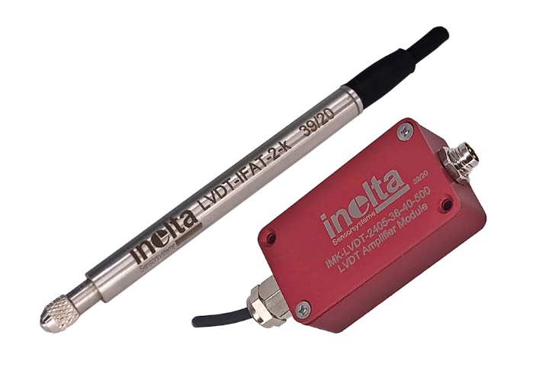
Caption: In perfect harmony: IFAT-LVDT and IMK-LVDT-2405 measuring amplifier

The sensor specialist also offers customized adaptations and modifications for the new solution on request at competitive conditions – as it would for all of its sensors and systems. Inelta covers a wide range of applications with its range of miniature LVDTs with housing diameters from 1.8 mm to 8 mm. In addition to medical and laboratory applications, this also includes control technology, the manufacture of precision parts, and dynamic position determination in chassis or on test benches. For robust applications with longer measurement ranges, Inelta offers LVDTs with diameters up to 32 mm, versions with M12 and M18 external threads, with pneumatic function as well as models for hydraulic applications and pressures up to 400 bar, and much more. In addition, the sensor specialist also develops special solutions and complete systems for special applications in close coordination with customers.

Application know-how is key
The measurement solution reliability not only depends on the use of robust sensor technology, but also on specific design features of the selected sensor models, their application-specific configuration, and correct placement. That is why Inelta as a specialist in industrial sensor technology supports its customers with comprehensive application know-how, in-depth advice and, where required, also carries out custom-fit modifications to its products.

Image/s: | 202103026_ifat | Characters: | 1,978
File name: | 202109017_pm_ifat_en | Date: | 12-08-2021

Company background
Inelta Sensorsysteme GmbH & Co. KG with its headquarters in Taufkirchen near Munich has been developing, producing, and selling standard and customized sensor solutions for industrial applications for more than 25 years. Together with PIL Sensoren GmbH (Erlensee near Frankfurt/Main), an ultrasonic sensor system pioneer, and VYPRO s.r.o. (Trenčín, Slovakia), the company offers a wide range of products for measuring displacement and position as well as force, pressure and inclination measurement. The range includes force sensors, sensor signal amplifiers, 201pressure switches, capacitive sensors and ultrasonic sensors. Our portfolio is nicely rounded off with cable and connector assembly services.
Most of the group of companies’ customers are in industrial automation, mechanical engineering, hydraulics, medical technology as well as the aerospace industry. We especially focus on industry and customer-specific sensor solutions and are constantly expanding this focus with interdisciplinary know-how.

Contact:  Inelta Sensorsysteme GmbH & Co. KG  Reinhard Koch  Ludwig-Bölkow-Allee 22  82024 Taufkirchen  Phone: 0 89 / 45 22 45-0  Fax: 0 89 / 45 22 45-744  eMail: reinhard.koch@inelta.de  Internet: www.inelta.de |  | gii die Presse-Agentur GmbH  Immanuelkirchstraße 12  10405 Berlin  Phone: 0 30 / 53 89 65-0  Fax: 0 30 / 53 89 65-29  eMail: info@gii.de  Internet: www.gii.de

