Press release

Replaceable at full process pressure:
New LVDT valve sensors with a modular design

With their special modular construction, the LVDT-based valve sensors in the IHDL-M16 series from Inelta Sensorsysteme allow the sensor module to be replaced while the process is running. Whereas in conventional LVDTs used in hydraulic applications, the sensor technology with the coil windings and the pressure-encapsulated tube for the core or core extension form one unit, the IHDL-M16 series has the advantage that the pressure tube and sensor are mounted separately for linear displacement transducers. In addition to that, the core extension is connected to the valve first and then sealed by the pressure pipe with an M16x1.5 flange on the process side.

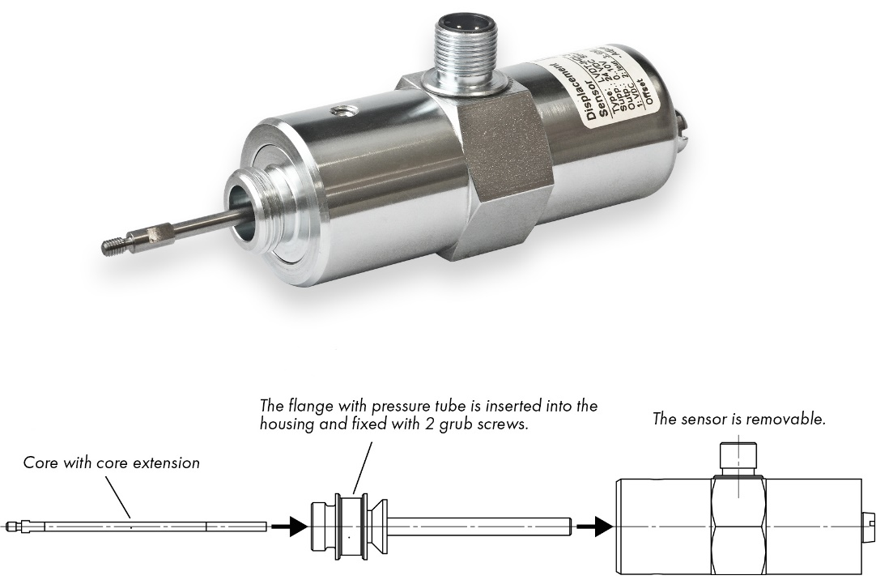

Image: Valve sensor IHDL-M16: The sensor module can be replaced while the process is ongoing thanks to the modular design with a separate pressure tube.

The sensor can then be slid over the pressure pipe and removed at any time for servicing without interrupting the ongoing process. Pressure pipe and flange are designed for pressures up to 550 bar. The new valve sensors feature measurement ranges of up to 40 mm despite being particularly short. Thanks to the absolute measuring principle, the sensors always recognize the correct core position again after a service has been carried out or in the event of a power failure. There are two potentiometers protected by sealing screws on the back of the housing for setting the offset and gain. When requested to do so, Inelta is also glad to support its customers with the realization and implementation of special measurement solutions. Thanks to its engineers’ comprehensive application know-how combined with production in Germany, the manufacturer is able to create special solutions or modify series sensors for customer-specific requirements at short notice.

Application know-how is key
The measurement solution reliability not only depends on the use of robust sensor technology, but also on specific design features of the selected sensor models, their application-specific configuration, and correct placement. That is why Inelta as a specialist in industrial sensor technology supports its customers with comprehensive application know-how, in-depth advice and, where required, also carries out custom-fit modifications to its products.

Image/s: | ventilsensor_ihdl_m16_en_2000px.jpg | Characters: | 2,103
File name: | 202109021_pm_IHDL-M16_fuer_Hydraulikanwendungen_en | Date: | 12-15-2021
Company background
Inelta Sensorsysteme GmbH & Co. KG with its headquarters in Taufkirchen near Munich has been developing, producing, and selling standard and customized sensor solutions for industrial applications for more than 25 years. Together with PIL Sensoren GmbH (Erlensee near Frankfurt/Main), an ultrasonic sensor system pioneer, and VYPRO s.r.o. (Trenčín, Slovakia), the company offers a wide range of products for measuring displacement and position as well as force, pressure and inclination measurement. The range includes force sensors, sensor signal amplifiers, pressure switches, capacitive sensors and ultrasonic sensors. Our portfolio is nicely rounded off with cable and connector assembly services.
Most of the group of companies’ customers are in industrial automation, mechanical engineering, hydraulics, medical technology as well as the aerospace industry. We especially focus on industry and customer-specific sensor solutions and are constantly expanding this focus with interdisciplinary know-how.

Contact:  Inelta Sensorsysteme GmbH & Co. KG  Reinhard Koch  Ludwig-Bölkow-Allee 22  82024 Taufkirchen  Phone: 0 89 / 45 22 45-0  Fax: 0 89 / 45 22 45-744  eMail: reinhard.koch@inelta.de  Internet: www.inelta.de |  | gii die Presse-Agentur GmbH  Immanuelkirchstraße 12  10405 Berlin  Phone: 0 30 / 53 89 65-0  Fax: 0 30 / 53 89 65-29  eMail: info@gii.de  Internet: www.gii.de

