Press release

Inelta is expanding its range of bending beams

Inelta is continuing to extend its range of bending beams with the FT21 series. The tension and compression force transducers with low space requirements and an integrated measuring amplifier combined with high linearity are used for measuring small and medium sized forces. Through-holes are used to make integration and fastening easy. The FT21 bending beams with the dimensions 68 mm x 28.5 mm x 26 mm are intended for the range 0.2 kN to 1 kN while the model dimensions for 2 kN to 10 kN are 78 mm x 31.5 mm x 33 mm. The type of output signals can be selected from various voltage or current outputs. The degree of protection on the double bending beam sensor is IP64. With a nominal temperature range of -20 °C to +60 °C, it is suitable for applications from stage technology, cranes, lifts and lifting technology, to production machines, material testing, presses, or welding systems. With its product portfolio, Inelta provides a comprehensive bending beam program from 100 N to 10 kN in different size categories.

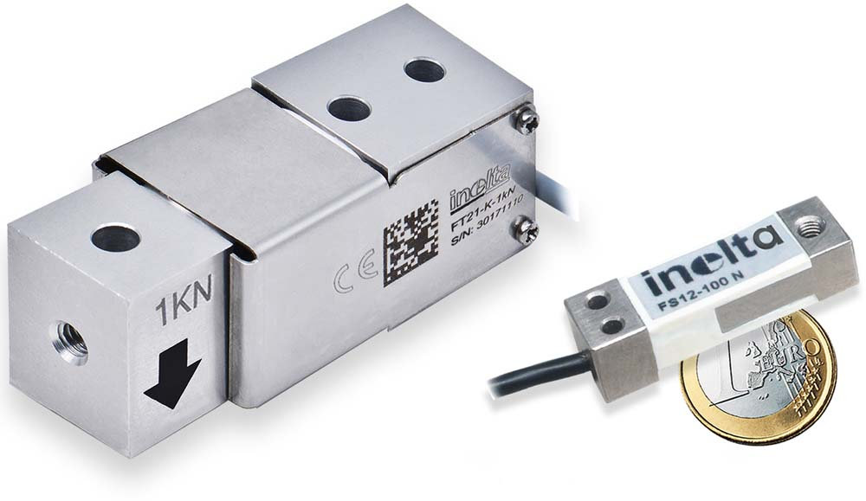

Caption: FT21, the strongest and FS12, the smallest of Inelta’s bending beams

Application know-how is key
The measurement solution reliability not only depends on the use of robust sensor technology, but also on specific design features of the selected sensor models, their application-specific configuration, and correct placement. That is why Inelta as a specialist in industrial sensor technology supports its customers with comprehensive application know-how, in-depth advice and, where required, also carries out custom-fit modifications to its products.

Image/s: | FT21_FS12_2000px | Characters: | 1,501
File name: | 202109024_pm_Inelta_FT21_Programmerweiterung_Biegebalken_en | Date: | 01-19-2022

Company background
Inelta Sensorsysteme GmbH & Co. KG with its headquarters in Taufkirchen near Munich has been developing, producing, and selling standard and customized sensor solutions for industrial applications for more than 25 years. Together with PIL Sensoren GmbH (Erlensee near Frankfurt/Main), an ultrasonic sensor system pioneer, and VYPRO s.r.o. (Trenčín, Slovakia), the company offers a wide range of products for measuring displacement and position as well as force, pressure and inclination measurement. The range includes force sensors, sensor signal amplifiers, pressure switches, capacitive sensors and ultrasonic sensors. Our portfolio is nicely rounded off with cable and connector assembly services.
Most of the group of companies’ customers are in industrial automation, mechanical engineering, hydraulics, medical technology as well as the aerospace industry. We especially focus on industry and customer-specific sensor solutions and are constantly expanding this focus with interdisciplinary know-how.

Contact:  Inelta Sensorsysteme GmbH & Co. KG  Reinhard Koch  Ludwig-Bölkow-Allee 22  82024 Taufkirchen  Phone: 0 89 / 45 22 45-0  Fax: 0 89 / 45 22 45-744  eMail: reinhard.koch@inelta.de  Internet: www.inelta.de |  | gii die Presse-Agentur GmbH  Immanuelkirchstraße 12  10405 Berlin  Phone: 0 30 / 53 89 65-0  Fax: 0 30 / 53 89 65-29  eMail: info@gii.de  Internet: www.gii.de

