Press Release

Fluke Process Instruments Debuts SV600 Fixed Acoustic Imager for Manufacturing Environments

Fluke Process Instruments, a global leader in infrared imaging and thermal profiling solutions for industrial applications, releases its first fixed acoustic imaging solution. The SV600 Fixed Acoustic Imager enables users to detect, locate and visualize air and gas leaks or changes in sound signatures across their process and equipment in real-time before they become costly problems. By using an array of sophisticated sound sensors and powerful SoundMap technology, the SV600 translates the sounds that it hears into a visual representation so users can quickly locate and quantify problem areas.
The SV600 easily integrates with factory systems and can serve as an early warning system that can quickly detect changes across compressors, pumps, pipes, conveyors or across product inspection and quality control processes, and much more with user-defined alarms. Remote evaluation options, meanwhile, help to minimize operator intervention, even in parts of the facility that are hard to reach.

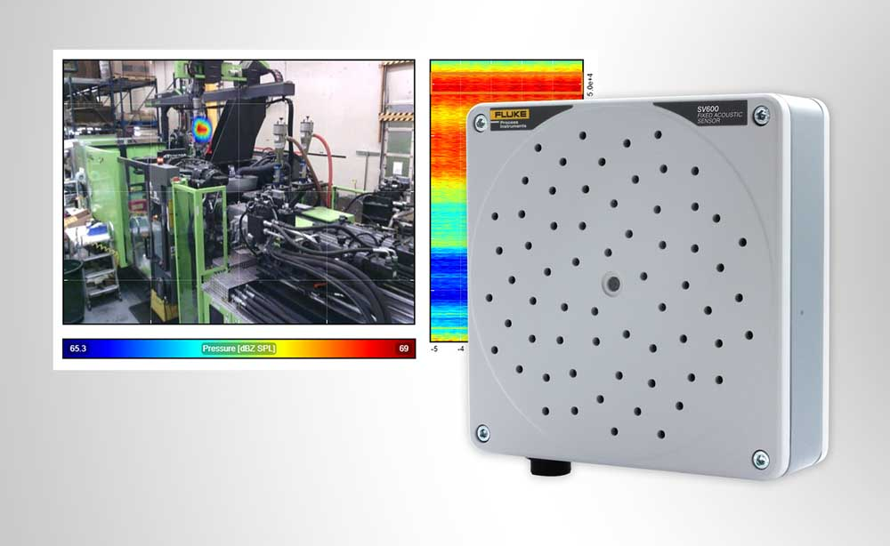
Caption: The SV600 Fixed Acoustic Imager detects and locates gas leaks as well as mechanical faults and weaknesses

“With automated acoustic imaging that the SV600 brings, maintenance teams can visualize leaks or sound signature changes to factory equipment or assets, and prevent unscheduled maintenance and possible costly downtime, and at the same time improve factory safety by minimizing operator intervention,” says Herman Warnshuis, president, Fluke Process Instruments. “We are excited to bring this new technology to customers across the globe and cannot wait to see how they utilize the technology to detect, locate and visualize sound signature changes or leaks in their process.”
The SV600 can also be used a payload for Boston Dynamics’ agile mobile robot Spot, which takes inspection to the next level. Designed to go where other robots cannot go and to perform a broad number of tasks, Spot traverses large facilities or unstructured terrain to automate industrial inspections, monitor remote or difficult-to-access environments and provide situational awareness in remote settings. With the SV600 payload, Spot can be reconfigured to automate air and gas leak detection, increase maintenance team efficiency, greatly reduce safety risks and reduce energy costs.
The SV600 Fixed Acoustic Imager is now available.
More information: https://lp.flukeprocessinstruments.com/sv600/fixed-acoustic-imager/pr/

 | Image/s: | sv600_fixed_acoustic_imager |  | Characters: | 2206
 | File name: | 202110017_pm_sv600_fixed_acoustic_imager_en |  | Date: | 10-19-2021
About Fluke Process Instruments
Fluke Process Instruments designs, manufactures, and markets a complete line of infrared temperature measurement and profiling solutions for industrial, maintenance, and quality control applications. Distributed worldwide under the Raytek, Ircon, and Datapaq brands, the products reflect the combined experience of over 150 years in manufacturing the world’s finest temperature measurement tools and devices.
About Fluke
Founded in 1948, Fluke Corporation is the world leader in compact, professional electronic test tools. Fluke customers are technicians, engineers, electricians, and metrologists who install, troubleshoot, and manage industrial, electrical, and electronic equipment and calibration processes.
Contact:  Fluke Process Instruments GmbH  Blankenburger Str. 135  13127 Berlin  Germany  Phone: +49 . 30 . 478 008-0  Email: marketing@flukeprocessinstruments.de  Internet: www.flukeprocessinstruments.com |  |  | gii die Presse-Agentur GmbH  Immanuelkirchstr. 12  10405 Berlin  Germany  Phone: +49 . 30 . 538 965-0  Email: info@gii.de  Internet: www.gii.de

