Press Release

Rotary kiln monitoring
Fluke Process Instruments releases CS400 Kiln Shell Imaging System

Fluke Process Instruments, a global leader in infrared imaging and thermal profiling solutions for industrial applications, debuts its latest temperature monitoring system – the CS400 Kiln Shell Imaging System. Specifically designed for harsh kiln environments, the CS400 is a fully integrated solution that continuously monitors rotary kilns for hot spots and can picture every brick in real-time to detect wear and tear, prevent costly damages and unscheduled downtime, and extend production runs and the kiln’s operational life. At the core of the system is the MP Linescanner, which provides accurate, edge-to-edge and real-time thermal imaging and temperature measurement for a complete picture of continuous processes.

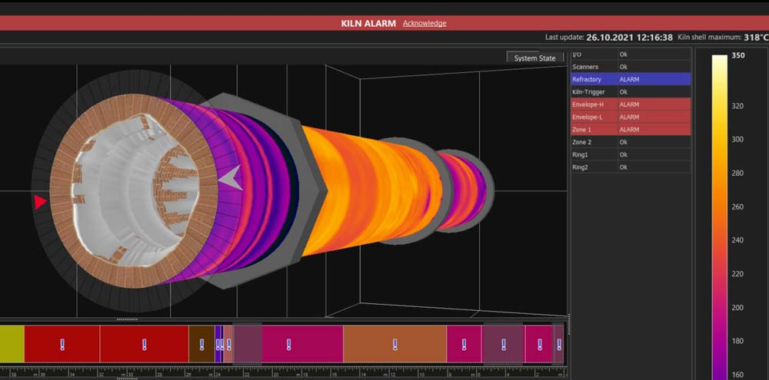
Caption: The CS400 Kiln Shell Imaging System, based on an infrared linescanner, enables continuous monitoring of rotary kilns to detect and report wear and tear of the refractory in real-time

The CS400 features specially designed software, which relies on standard Ethernet ports. Because the graphic user interface is designed specifically for kiln applications, the software is easy to set up and use with little operator training required. Once set up, the software provides a thermal image of the entire kiln shell surface, with a zoom function that allows detailed examination for key areas of interest. Temperature range and zone alarms can also be easily configured within the software; and other information – such as burn zone temperature, lap time and the scanner’s internal temperature – is displayed in the status bar for a complete system status without changing screens.
“Continuous infrared monitoring is essential for rapid detection of temperature anomalies, such as non-uniformities and hot spots in a kiln’s refractory material,” says Stewart Griffiths, Global Product Manager, Fluke Process Instruments. “Our new Kiln Shell Imaging System can measure up to 1024 temperature points across a scan line and features specially-developed software. With multiple kiln support, polar charts highlighting coating thickness and brick thickness, and envelope profiles over the entire kiln, manufacturers can easily optimize and manage maintenance schedules to avoid costly shutdowns, as well as reduce setup times with intuitive configurations and temperature profile calculations.”
The CS400 Kiln Shell Imaging System is now available. To start picturing every brick in rotary kilns in real-time and contact a subject matter expert, visit https://get.flukeprocessinstruments.com/cs400/emedia/.

Image/s: | cs400_kiln_shell_3d_view | Characters: | 2334
File name: | 202111022_pm_cs400_kiln_shell_imager_en | Date: | 11-18-2021
About Fluke Process Instruments
Fluke Process Instruments designs, manufactures, and markets a complete line of infrared temperature measurement and profiling solutions for industrial, maintenance, and quality control applications. Distributed worldwide under the Raytek, Ircon, and Datapaq brands, the products reflect the combined experience of over 150 years in manufacturing the world’s finest temperature measurement tools and devices.
About Fluke
Founded in 1948, Fluke Corporation is the world leader in compact, professional electronic test tools. Fluke customers are technicians, engineers, electricians, and metrologists who install, troubleshoot, and manage industrial, electrical, and electronic equipment and calibration processes.
Contact:  Fluke Process Instruments GmbH  Blankenburger Str. 135  13127 Berlin  Germany  Phone: +49 . 30 . 478 008-0  Email: marketing@flukeprocessinstruments.de  Internet: www.flukeprocessinstruments.com |  | gii die Presse-Agentur GmbH  Immanuelkirchstr. 12  10405 Berlin  Germany  Phone: +49 . 30 . 538 965-0  Email: info@gii.de  Internet: www.gii.de

