Press Release

Highly compact OLED display module for force sensors

Inelta Sensorsysteme has introduced the IMK-2442-OLED cable electronics as a new digital display unit for strain gauge force sensors with integrated measuring amplifier. With dimensions of only 60x35x22mm, the particularly compact display module with OLED display can be easily integrated into the signal transmission via sensor cable using a plug and socket in M12 format. The display unit, which is compatible with all sensors with a current output of 4...20mA, optionally indicates the output values of force sensors in newtons or milliamps, but can also display the movement in millimeters e.g. for LVDT sensors. The display updates the display values at 100ms intervals. This makes the module suitable for all applications where measured values in newtons, mA or mm are required near the sensor without applying the display directly to the sensor. Due to the robust housing made of anodized aluminum and the electronics protected by potting compound, the display unit, which is manufactured in protection class IP64, can permanently withstand even demanding operating conditions in a temperature range from -10°C to +60°C. To complete the range, Inelta has announced the market launch of a further device variant with voltage output 0...10V. In addition, the manufacturer already offers the IMK-DMS-OLED model, a highly compact solution for strain gauge-based force sensors without their own measuring amplifier. This series is equipped with the complete amplifier electronics for a force sensor with strain gauge bridge circuit and displays the force applied to the force sensor in Newton as well as the measuring range and the calibration date.

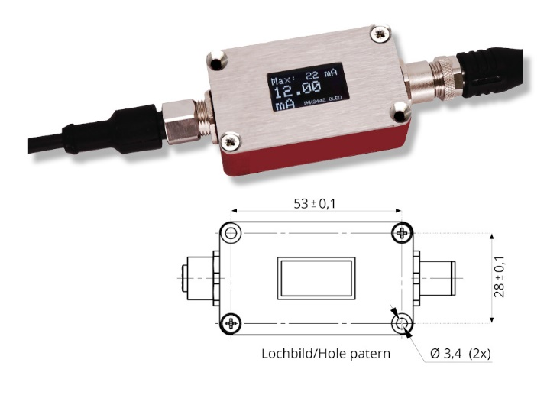
Caption: Highly compact cable electronics with OLED display for sensors with integrated measuring amplifier

Image/s: | IMK-2442-OLED_2000.jpg | Characters: | 1,651
File name: | 202302008_pm_digit-anz-kraftsensor_en.docx | Date: | 02-15-2023
About Inelta
Inelta Sensorsysteme GmbH & Co. KG with its headquarters in Taufkirchen near Munich has been developing, producing, and selling standard and customized sensor solutions for industrial applications for more than 25 years. Together with PIL Sensoren GmbH (Erlensee near Frankfurt/Main), an ultrasonic sensor system pioneer, and VYPRO s.r.o. (Trenčín, Slovakia), the company offers a wide range of products for measuring displacement and position as well as force, pressure and inclination measurement. The range includes force sensors, sensor signal amplifiers, pressure switches, capacitive sensors and ultrasonic sensors. Our portfolio is nicely rounded off with cable and connector assembly services.
Most of the group of companies’ customers are in industrial automation, mechanical engineering, hydraulics, medical technology as well as the aerospace industry. We especially focus on industry and customer-specific sensor solutions and are constantly expanding this focus with interdisciplinary know-how.
Contact:  Inelta Sensorsysteme GmbH & Co. KG  Reinhard Koch  Ludwig-Bölkow-Allee 22  82024 Taufkirchen  Germany  Phone: +49 89 452 245-0  Fax: +49 89 452 245-744  Email: reinhard.koch@inelta.de  Internet: www.inelta.de |  | gii die Presse-Agentur GmbH  Immanuelkirchstr. 12  10405 Berlin  Germany  Phone: +49 30 538 965-0  Fax: +49 30 538 965-29  Email: info@gii.de  Internet: www.gii.de

