Press Release

SENSOR+TEST & SMTconnect:
Thermal camera premiere and reflow temperature profiling

Fluke Process Instruments will be showcasing its temperature measurement solutions at the SENSOR+TEST and SMTconnect trade fairs in Nuremberg, Germany, May 9 – 11, 2023. At the SENSOR+TEST, the manufacturer will premiere the brand-new standalone thermographic camera ThermoView TV30 with an integrated web server. The new infrared camera for fixed installation is designed for 24/7 monitoring of manufacturing processes and equipment to ensure operational safety and quality compliance. It has a wide measuring range of -10 °C – 1300 °C (14 °F – 2372 °F), can be easily connected to a PLC via OPC UA or MQTT and transmits measurement data and analyses in real time. Additional solutions at the Fluke Process Instruments SENSOR+TEST booth cover virtually all industrial applications: rugged infrared sensors including explosion-proof versions, miniaturized spot pyrometers for cost-sensitive OEM measurement solutions, line scanners for thermal imaging in moving processes and a wide range of accessories for demanding industrial environments.
At the SMTconnect, the team will present Datapaq systems for temperature profiling inside soldering ovens. The Datapaq Reflow Tracker range includes numerous compact solutions for all oven types and designs. The temperature profiling systems each consist of a data logger, thermal barrier, thermocouples and software. The tested and proven systems facilitate oven setup, quality control and auditing according to various standards.

Contact the manufacturer
Fluke Process Instruments booth numbers:
SENSOR+TEST #1-341
SMTconnect #4-111

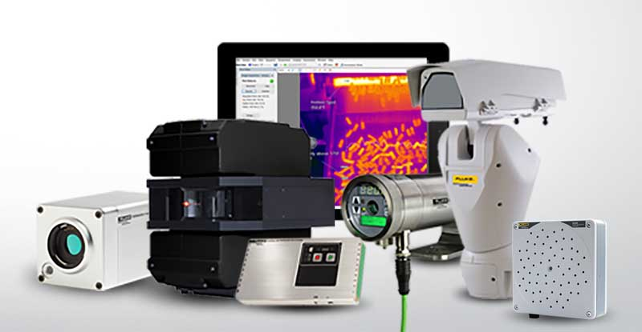
Caption: Fluke Process Instruments offers rugged temperature measurement solutions and acoustic imagers along with versatile software tools for various industry applications

Image/s: | fluke_process_instruments_w_sv600 | Characters: | 1473
File name: | 202303028_pm_sensor-test_smtconnect_en | Date: | 05-08-2023
About Fluke Process Instruments
Fluke Process Instruments designs, manufactures, and markets a complete line of infrared temperature measurement and profiling solutions for industrial, maintenance, and quality control applications. Distributed worldwide under the Raytek, Ircon, and Datapaq brands, the products reflect the combined experience of over 150 years in manufacturing the world’s finest temperature measurement tools and devices.
About Fluke
Founded in 1948, Fluke Corporation is the world leader in compact, professional electronic test tools. Fluke customers are technicians, engineers, electricians, and metrologists who install, troubleshoot, and manage industrial, electrical, and electronic equipment and calibration processes.
Contact:  Fluke Process Instruments GmbH  Blankenburger Str. 135  13127 Berlin  Germany  Phone: +49 . 30 . 478 008-0  Email: marketing@flukeprocessinstruments.de  Internet: www.flukeprocessinstruments.com |  | gii die Presse-Agentur GmbH  Immanuelkirchstr. 12  10405 Berlin  Germany  Phone: +49 . 30 . 538 9650  Email: info@gii.de  Internet: www.gii.de

