Press Release

Maintenance NEXT:
Acoustic Imaging and Thermal Imaging

Fluke Process Instruments will present its acoustic and thermal imagers at Maintenance NEXT alongside Avular at Hall 2, Booth 106. The two manufacturers’ solutions complement one another perfectly as shown by the new working model for mobile, remote-controlled acoustic imaging. Fluke Process Instruments’ SV600 Fixed Acoustic Imager for gas leak detection is mounted on an Avular Origin One autonomous robot for easy maneuvering, which provides an efficient and safe way to inspect hard-to-access sites as well as environments that are deemed potentially unsafe for humans. The acoustic imager employs an array of sophisticated sound sensors, a camera and Fluke’s powerful SoundMap technology to detect and visualize gas leaks, allowing service personnel to repair them quickly before they incur mounting costs. The system easily integrates with factory systems and enables 24/7 monitoring of compressors, pumps, pipes and other equipment with user-defined alarms. Additional Fluke Process Instruments exhibits will include thermal cameras, infrared sensors for continual process and asset monitoring, and handheld Fluke devices for spot-checking.
Fluke Process Instruments at Maintenance NEXT
Rotterdam, 18 – 20 April 2023
Hall 2, Booth 106

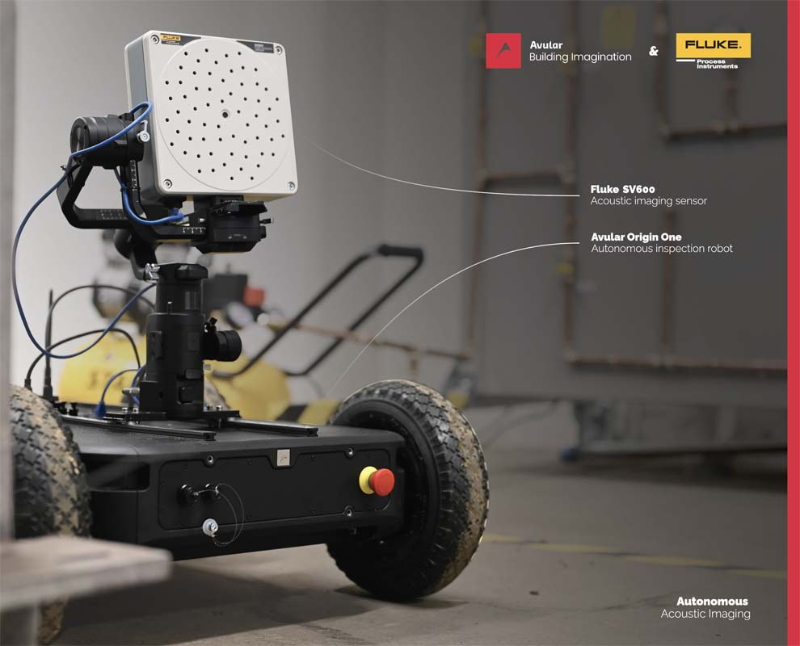
Caption: Fluke Process Instruments and Avular demonstrate a new solution for acoustic imaging on the go – an efficient and safe way to inspect inhospitable or hard-to-access sites

Image/s: | fluke_sv600_with_avular_autonomous_robot | Characters: | 1148
File name: | 202304048_pm_maintenance_next_en | Date: | 04-12-2023
About Fluke Process Instruments
Fluke Process Instruments designs, manufactures, and markets a complete line of infrared temperature measurement and profiling solutions for industrial, maintenance, and quality control applications. Distributed worldwide under the Raytek, Ircon, and Datapaq brands, the products reflect the combined experience of over 150 years in manufacturing the world’s finest temperature measurement tools and devices.
About Fluke
Founded in 1948, Fluke Corporation is the world leader in compact, professional electronic test tools. Fluke customers are technicians, engineers, electricians, and metrologists who install, troubleshoot, and manage industrial, electrical, and electronic equipment and calibration processes.
Contact:  Fluke Process Instruments GmbH  Blankenburger Str. 135  13127 Berlin  Germany  Phone: +49 . 30 . 478 008-0  Email: marketing@flukeprocessinstruments.de  Internet: www.flukeprocessinstruments.com |  | gii die Presse-Agentur GmbH  Immanuelkirchstr. 12  10405 Berlin  Germany  Phone: +49 . 30 . 538 9650  Email: info@gii.de  Internet: www.gii.de

