Press release

Force sensors for static and dynamic measurements

Inelta Sensorsysteme has a comprehensive product range of force sensors for precise dynamic and static measurements in all industrial areas of mechanical engineering, automation technology, laboratory, and medical technology as well as for special applications. The range of force sensors based on foil strain gauges (DMS) includes the KMM65 series designed for measuring ranges from 1 kN to 500 kN. Designed for pressure and tension measurement in industrial presses, testing or weighing systems, the robust transducers in nickel-plated steel housings - or optional stainless steel versions - achieve protection class IP65. With the KMM30 and KMM62 models, the sensor specialist stocks compact sensors for absorbing small forces of 0.1 kN to 2 kN in tension and compression, which are easy to mount thanks to regular standard threads. In addition, Inelta offers ring force transducers for measuring axial forces on screws, shafts or axles. Typical applications include the determination of preload forces on bolted connections. The ring force transducers of the RKT60 series, manufactured in protection class IP 67, are designed for nominal forces from 5 kN to 20 kN. They integrate overload protection and a measuring amplifier with 4..20 mA analog output and are protected against vibration, dust and moisture by potting. For tactile force measurements in medical devices and robot arms or for load testing of small components, Inelta has developed the FS12 miniature force transducer for compression and tension forces up to 100 N, 200 N and 500 N, respectively. Weighing only 20 g, this bending beam force sensor is the smallest force sensor in the product range. The company, which has its own development and production facilities at its headquarters in Taufkirchen, also manufactures customer-specific modified sensor technology or complete special solutions on request. In addition, Inelta offers an accredited calibration service for force sensors through its sister company Vypro Sensors (www.vypro.de).

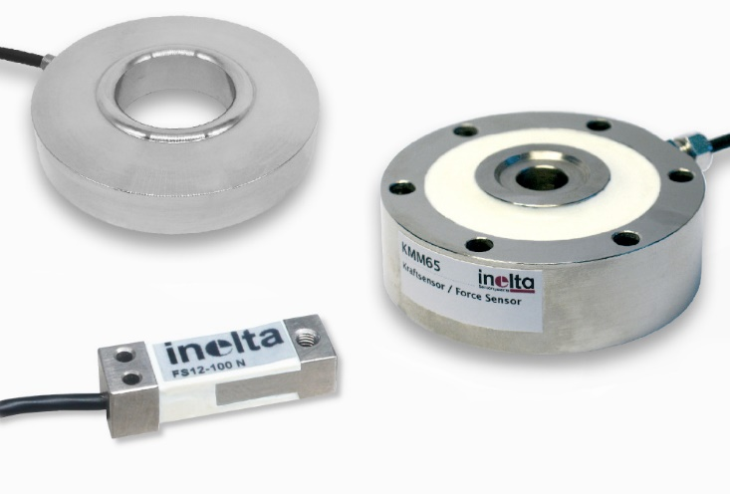
Caption: Sensor specialist Inelta has an extensive range of force sensors for a wide variety of measuring and application areas

Image/s: | kraftsensoren_dreierlei_2000px.jpg | Characters: | 2,014
File name: | 202306007_pm_force-sensors_en.docx | Date: | 06-07-2023

About Inelta
Inelta Sensorsysteme GmbH & Co. KG with its headquarters in Taufkirchen near Munich has been developing, producing, and selling standard and customized sensor solutions for industrial applications for more than 25 years. Together with PIL Sensoren GmbH (Erlensee near Frankfurt/Main), an ultrasonic sensor system pioneer, and VYPRO s.r.o. (Trenčín, Slovakia), the company offers a wide range of products for measuring displacement and position as well as force, pressure and inclination measurement. The range includes force sensors, sensor signal amplifiers, pressure switches, capacitive sensors and ultrasonic sensors. Our portfolio is nicely rounded off with cable and connector assembly services.
Most of the group of companies’ customers are in industrial automation, mechanical engineering, hydraulics, medical technology as well as the aerospace industry. We especially focus on industry and customer-specific sensor solutions and are constantly expanding this focus with interdisciplinary know-how.

Contact:

Inelta Sensorsysteme GmbH & Co. KG
Reinhard Koch
Ludwig-Bölkow-Allee 22
82024 Taufkirchen
Tel.: 0 89 / 45 22 45-0
Fax: 0 89 / 45 22 45-744
E-Mail: reinhard.koch@inelta.de

Internet: www.inelta.de

