Press Release

Sensor specialist with great LVDT expertise

Due to many years of experience, own coil and LVDT production, Inelta Sensorsysteme is considered a proven specialist in the development and production of these inductive precision sensors. Due to their non-contact measuring principle, the hysteresis-free LVDTs achieve a virtually unlimited resolution, which depends only on the quality of the signal amplification. With their high measurement precision, repeatability, and principle-based freedom from wear, they are therefore ideal for applications requiring maximum reliability and long service life. Inelta's wide range of LVDTs includes the LVDT-ISDP and LVDT-ISAP series with pneumatic push rod for measuring travels from 5 mm to 50 mm. The inductive sensors, which are available both with and without an integrated measuring amplifier in three device sizes, enable exact position determination of, for example, plate materials with a measuring accuracy of up to ≤0.1 mm. For long-term monitoring of bridge statics, Inelta's product range includes the LVDT-ISAG-300-k model, a weatherproof sensor that reliably detects even the smallest displacements at critical load points. The LVDT-IOAG series is tailored to particularly demanding environmental and operating conditions. The structure, welded housing and cable design reliably protect the LVDT from penetrating seawater or brackish water. This predestines this sensor version with 100 mm measuring travel for use, for example, in bridge surveying, heavy machinery, road and rail construction or railroad and power plant technology. In addition, Inelta assembles LVDTs for heavy machinery on request in robust hexagonal housings for customer-preferred wrench sizes to simplify sensor replacement under harsh conditions. Supplementary, the manufacturer can modify the LVDT designs to suit specific applications, for example with a sensing function, as a displacement transducer with a continuous push rod or with oil compensation holes. Inelta also offers suitable solutions for inductive displacement measurement in miniature format, such as the IKDT displacement sensor in a stainless-steel housing. With a diameter of only 8 mm and sensing lengths of 2, 5, 10 and 20 mm, the miniature sensor with integrated measuring amplifier requires only minimal installation space and measures extremely precisely with a linearity deviation of only ±0.3 %.

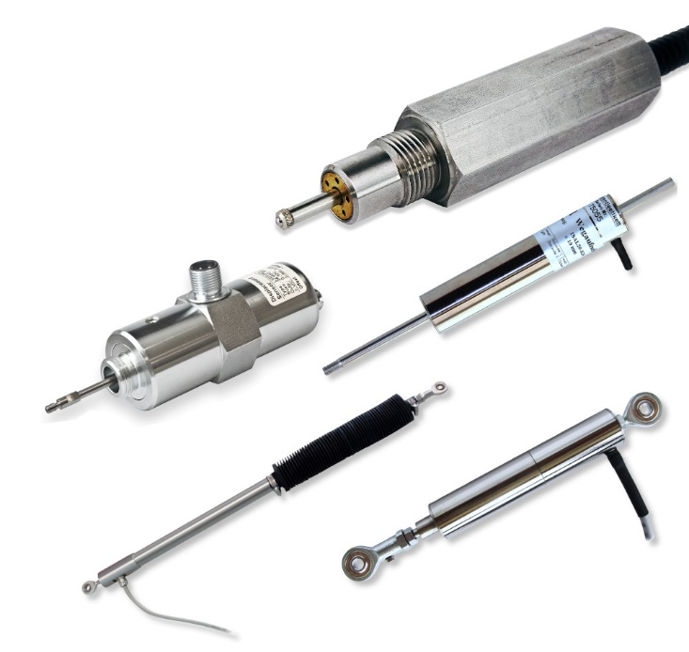
Caption: Inelta combines a high level of LVDT expertise with a wide range of products for a wide variety of applications, which can also be modified to meet specific customer requirements

Image/s: | lvdt-collage_2000px.jpg | Characters: | 2,357
File name: | 202307003_pm_lvdt-specialist_en.docx | Date: | 07-04-2023

About Inelta
Inelta Sensorsysteme GmbH & Co. KG with its headquarters in Taufkirchen near Munich has been developing, producing, and selling standard and customized sensor solutions for industrial applications for more than 25 years. Together with PIL Sensoren GmbH (Erlensee near Frankfurt/Main), an ultrasonic sensor system pioneer, and VYPRO s.r.o. (Trenčín, Slovakia), the company offers a wide range of products for measuring displacement and position as well as force, pressure and inclination measurement. The range includes force sensors, sensor signal amplifiers, pressure switches, capacitive sensors and ultrasonic sensors. Our portfolio is nicely rounded off with cable and connector assembly services.
Most of the group of companies’ customers are in industrial automation, mechanical engineering, hydraulics, medical technology as well as the aerospace industry. We especially focus on industry and customer-specific sensor solutions and are constantly expanding this focus with interdisciplinary know-how.

Contact:

Inelta Sensorsysteme GmbH & Co. KG
Reinhard Koch
Ludwig-Bölkow-Allee 22
82024 Taufkirchen
Tel.: 0 89 / 45 22 45-0
Fax: 0 89 / 45 22 45-744
E-Mail: reinhard.koch@inelta.de

Internet: www.inelta.de

