Press release

Accredited calibration service for force sensors

For a permanently high measurement reliability and precision of force sensors, their regular control and calibration within defined intervals are required. For this purpose, Inelta Sensorsysteme offers an accredited calibration service for force sensors through its subsidiary Vypro spol s.r.o. The Vypro calibration laboratory is accredited according to European standard ISO/IEC 17025: 2017 by the Slovak accreditation body SNAS for the mechanical measurand force. The calibration service includes both products of own manufacture and third-party products in the measurement range from 0.1kN to 200kN. Tensile and compressive force sensors, ring force sensors, but also bending and shear bars, tension measuring clips and special force sensors are tested. After checking the calibration capability of the test specimen, it is compared to a standard using an EN ISO 376 conform PP force gauge to correct deviations from the standard. An internationally recognized certificate or factory calibration certificate is issued by Vypro as proof of calibration. Traceability of the sensor calibration is ensured via the serial number. Furthermore, Vypro performs application-specific calibrations and offers a repair service for DUTs as well as an express service upon request. Detailed information and contact details for the calibration service are available on the company website at: https://www.vypro.de/en/expertise/calibration-service/

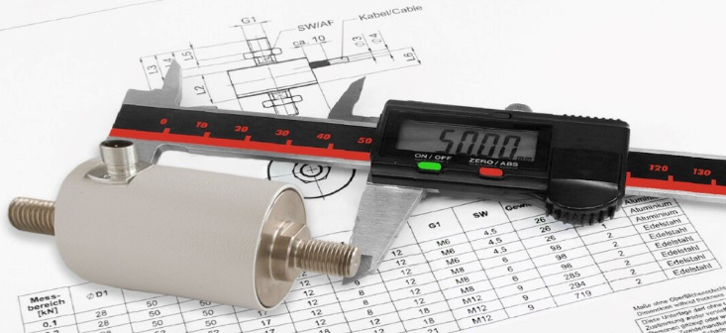
Caption: Inelta subsidiary Vypro offers an ISO/IEC accredited calibration service for force sensors of various types

Image/s: | vypro_kalib_kraftsensoren_2000px.jpg | Characters: | 1,436
File name: | 202309012_pm_ vypro_calibration_en.docx | Date: | 09-05-2023

About Inelta
Inelta Sensorsysteme GmbH & Co. KG with its headquarters in Taufkirchen near Munich has been developing, producing, and selling standard and customized sensor solutions for industrial applications for more than 25 years. Together with PIL Sensoren GmbH (Erlensee near Frankfurt/Main), an ultrasonic sensor system pioneer, and VYPRO s.r.o. (Trenčín, Slovakia), the company offers a wide range of products for measuring displacement and position as well as force, pressure and inclination measurement. The range includes force sensors, sensor signal amplifiers, pressure switches, capacitive sensors and ultrasonic sensors. Our portfolio is nicely rounded off with cable and connector assembly services.
Most of the group of companies’ customers are in industrial automation, mechanical engineering, hydraulics, medical technology as well as the aerospace industry. We especially focus on industry and customer-specific sensor solutions and are constantly expanding this focus with interdisciplinary know-how.

Contact:

Inelta Sensorsysteme GmbH & Co. KG
Reinhard Koch
Ludwig-Bölkow-Allee 22
82024 Taufkirchen
Tel.: 0 89 / 45 22 45-0
Fax: 0 89 / 45 22 45-744
E-Mail: reinhard.koch@inelta.de

Internet: www.inelta.de

