Press Release

Robotic acoustic inspection webinar

In a joint webinar on robotic acoustic inspection, Boston Dynamics and Fluke Process Instruments will show how to improve the energy efficiency of industrial operations through automatic compressed air leak detection by means of the SV600 Fixed Acoustic Imager and the agile mobile robot Spot. The webinar on 31 October 2023, at 11 a.m. EDT (7 a.m. UTC) will address how acoustic imaging is used to locate gas leaks and how the four-legged robot completes autonomous inspection walkarounds through complex environments. Application experts from Boston Dynamics and Fluke Process Instruments will present use cases with significant cost savings and instruct participants on how to utilize the technology for their inspection needs. The SV600 payload detects sounds even above the human hearing range – even in noisy industrial environments. Combining sound maps with visual images, it can exactly pinpoint gas leaks.
Webinar details and registration: https://bostondynamics.com/webinars/improving-energy-efficiency-with-robotic-acoustic-inspection/

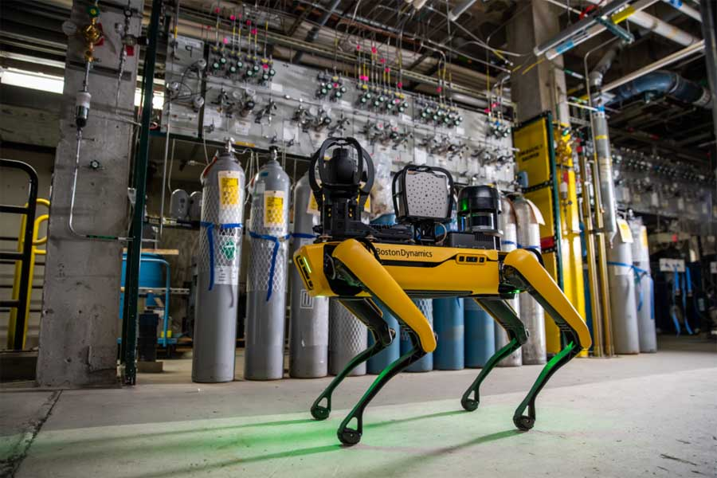
Caption: Spot safely and efficiently completes programmed inspection routines, carrying the SV600 payload which locates gas leaks

Image/s: | boston_dynamics_spot_w_sv600_fixed_acoustic_imager |  | Characters: | 1046
File name: | 202310026_pm_acoustic_inspection_webinar_en |  | Date: | 10-24-2023
About Fluke Process Instruments
Fluke Process Instruments designs, manufactures, and markets a complete line of infrared temperature measurement and profiling solutions for industrial, maintenance, and quality control applications. Distributed worldwide under the Raytek, Ircon, and Datapaq brands, the products reflect the combined experience of over 150 years in manufacturing the world’s finest temperature measurement tools and devices.
About Fluke
Founded in 1948, Fluke Corporation is the world leader in compact, professional electronic test tools. Fluke customers are technicians, engineers, electricians, and metrologists who install, troubleshoot, and manage industrial, electrical, and electronic equipment and calibration processes.
Contact:  Fluke Process Instruments GmbH  Blankenburger Str. 135  13127 Berlin  Germany  Phone: +49 30 478 0080  Email: marketing@flukeprocessinstruments.de  Internet: www.flukeprocessinstruments.com |  | gii die Presse-Agentur GmbH  Immanuelkirchstr. 12  10405 Berlin  Germany  Phone: +49 30 538 9650  Email: info@gii.de  Internet: www.gii.de

