Press Release

Fluke Process Instruments now Boston Dynamics’ Certified Technology Provider

The two technology companies have cooperated to perfect their solution for autonomous robotic acoustic inspection in industrial facilities.

Boston Dynamics has named Fluke Process Instruments a Certified Technology Provider, recognizing the company’s contribution to mobile acoustic inspection technology. Fluke Process Instruments has enabled its SV600 Fixed Acoustic Imager for integration as a payload in Boston Dynamics’ agile mobile robot Spot. One main application for the smart combo is the detection of compressed air and gas leaks in industrial plants. Users have reported savings from reduced compressed air leaks in the range of tens of thousands of dollars per month.
The manufacturers have been cooperating on making mobile sound detection capabilities available since 2021, launching a working system the same year. Recently, the companies announced the full integration of the acoustic camera payload in the versatile robot system – users can now program and remotely control acoustic measurements and inspection routes via the Spot dashboard and thus locate, analyze and remedy problems faster.

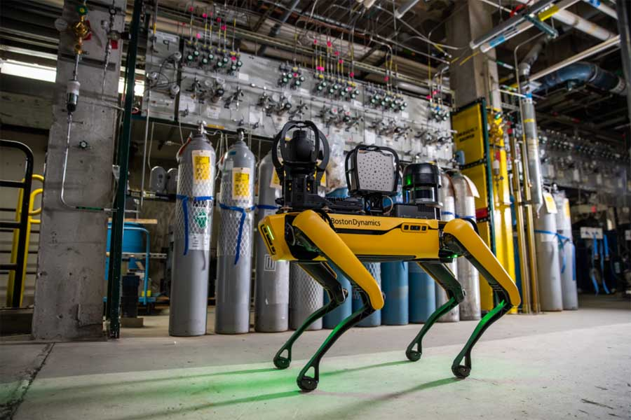
Caption: Boston Dynamics welcomes Fluke Process Instruments as a Certified Technology Provider to honor innovations facilitating autonomous mobile acoustic inspections

This cooperation was prompted by Boston Dynamics customers who were looking to boost their service personnel’s capacities and asked the robotics company to make the sound measuring capabilities of the handheld Fluke ii900 Industrial Acoustic Imager available with Spot. The initial inquiry led to a speedy dedicated product development by the group member Fluke Process Instruments, which has meanwhile found many uses besides as a Spot payload.
The SV600 acoustic imager features 64 digital MEMS microphones, a camera and a processor. It is sensitive even above human hearing and can detect even small gas leaks in noisy industrial environments. Its functions include noise classification, frequency filtering and mapping dB values and sound intensity. Results are visualized using Fluke’s powerful SoundMap technology. Operators from various industries use the data to improve their plants’ energy efficiency and garner cost savings through reduced compressed air losses and more timely, cheaper repair.
Spot can take over from plant staff as an autonomous inspection unit, carrying out menial and repetitive tasks with utmost precision and allowing technicians to focus on repair and maintenance. The robot completes programmed tours of industrial facilities, taking measurements as often as necessary, transmitting the results remotely and instantly and alerting personnel to user-defined events. It finds its way up and down stairs and around obstacles.

Image/s: | boston_dynamics_spot_w_sv600_fixed_acoustic_imager |  | Characters: | 2425
File name: | 202311034_pm_boston_dynamics_partner_en |  | Date: | 11-28-2023
About Fluke Process Instruments
Fluke Process Instruments designs, manufactures, and markets a complete line of infrared temperature measurement and profiling solutions for industrial, maintenance, and quality control applications. Distributed worldwide under the Raytek, Ircon, and Datapaq brands, the products reflect the combined experience of over 150 years in manufacturing the world’s finest temperature measurement tools and devices.
About Fluke
Founded in 1948, Fluke Corporation is the world leader in compact, professional electronic test tools. Fluke customers are technicians, engineers, electricians, and metrologists who install, troubleshoot, and manage industrial, electrical, and electronic equipment and calibration processes.
Contact:  Fluke Process Instruments GmbH  Blankenburger Str. 135  13127 Berlin  Germany  Phone: +49 30 478 0080  Email: marketing@flukeprocessinstruments.de  Internet: www.flukeprocessinstruments.com |  | gii die Presse-Agentur GmbH  Immanuelkirchstr. 12  10405 Berlin  Germany  Phone: +49 30 538 9650  Email: info@gii.de  Internet: www.gii.de

