Press Release

Thermal imagers for advanced factory automation, quality assurance and process monitoring

The ThermoView TV30 series from Fluke Process Instruments now offers two powerful thermal camera options: an edge sensor for standalone operation and a GigE version for advanced PC-based analysis.

Fluke Process Instruments extends its ThermoView TV30 series, launching a GigE thermographic camera in addition to the spearhead standalone version. The infrared cameras for fixed installation enable 24/7 thermal monitoring of processes and assets. They identify temperature anomalies and send alerts, allowing plant staff to rectify any problems early on and avoid poor quality output and damage to products and equipment.
The standalone version with onboard analytics and remote setup via web browser needs no PC in the field to automatically monitor up to 32 values for user-specified Areas of Interest (AOI) and criteria (max./min., average, spot temperature, standard deviation).

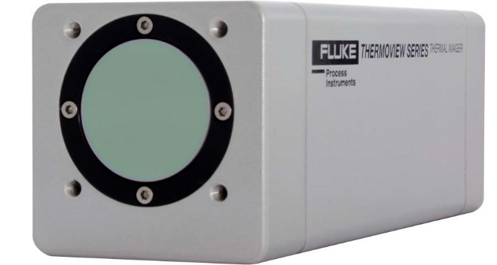
Caption: The ThermoView TV30 series offers two advanced options for thermography: a standalone thermal imager with onboard analytics, automatic alerts and an integrated web browser and a GigE PC-connected version for full integration in analysis applications such as Labview, Matlab or the proprietary ThermoView

The GigE version was designed to meet the most sophisticated requirements. It enables direct communication between programmers and the camera using standard applications like Labview or Matlab or the proprietary ThermoView software. It connects to a shop-floor or control-room PC and can stream thermal images at up to 60 frames per second. The ThermoView software provides an extensive array of features and functions for all typical industrial temperature monitoring and documentation needs. It supports an unlimited number of AOI, trending for those AOI and manual or automated archiving of images as well as measured values for traceability.
The thermal imagers can detect temperatures from -10 °C to 1300 °C (14 °F to 2372 °F). For improved accuracy, users can specify tighter temperature ranges. The imagers feature a rugged, IP67-rated housing. The series also provides a choice of two infrared camera resolution options, three lenses for different fields of view and protective accessories for demanding environments. All versions boast excellent connectivity, with multiple supported protocols for easy integration in plant-level automation systems and computerized maintenance management systems (CMMS).
More information: https://www.flukeprocessinstruments.com/thermoview-tv30

Image/s: | thermoview_tv30_8630 | Characters: | 1895
File name: | 202401012_pm_thermoview_tv30_gige_en | Date: | 01-24-2024
About Fluke Process Instruments
Fluke Process Instruments designs, manufactures, and markets a complete line of infrared temperature measurement and profiling solutions for industrial, maintenance, and quality control applications. Distributed worldwide under the Raytek, Ircon, and Datapaq brands, the products reflect the combined experience of over 150 years in manufacturing the world’s finest temperature measurement tools and devices.
About Fluke
Founded in 1948, Fluke Corporation is the world leader in compact, professional electronic test tools. Fluke customers are technicians, engineers, electricians, and metrologists who install, troubleshoot, and manage industrial, electrical, and electronic equipment and calibration processes.
Contact:  Fluke Process Instruments GmbH  Blankenburger Str. 135  13127 Berlin  Germany  Phone: +49 30 478 0080  Email: marketing@flukeprocessinstruments.de  Internet: www.flukeprocessinstruments.com |  | gii die Presse-Agentur GmbH  Immanuelkirchstr. 12  10405 Berlin  Germany  Phone: +49 30 538 9650  Email: info@gii.de  Internet: www.gii.de

