Press release

New ring force sensors with galvanically isolated input

Inelta Sensorsysteme has added new model variants to its portfolio of ring force sensors. The sensor type, which acts as a measuring washer, is used to detect axially acting forces on screws, shafts or axles and is used, for example, to determine or monitor preload forces on screw connections. The ring force sensors in the RKT60 series are now available for four nominal loads of 5, 10, 15 and 20 kN. The series is characterized by a compact deformation body made of stainless steel, a low overall height and mechanical overload protection. To protect against contact, dust and moisture, the manufacturer also offers the sensors in a molded version. Inelta also offers model variants with an integrated measuring amplifier. These units with strain gauge full bridge, stainless steel deformation body and extremely flat contact surface are particularly resistant to eccentric forces. Another innovation is the RKT120 series of ring force sensors with IP67 protection and a nominal force of 10 kN. The sensors, which are protected against dust and moisture by encapsulation, have a compact stainless steel deformation body, low overall height and integrated electronics with an electrically isolated safety function for testing the measuring bridge. This safety feature is particularly needed in event technology to ensure the safety of people and loads moving on stages. The new RKT120 series, designed for a temperature range of -15 °C to +75 °C, integrates a measuring amplifier with analog output and is also transverse force tolerant due to the convex force transmission. Inelta offers its ring force sensors with or without electronics and can adapt them to customer-specific requirements if necessary. The sensor specialist's range is rounded off by highly compact, digital display modules with OLED display for strain gauge force sensors with or without integrated measuring amplifier.

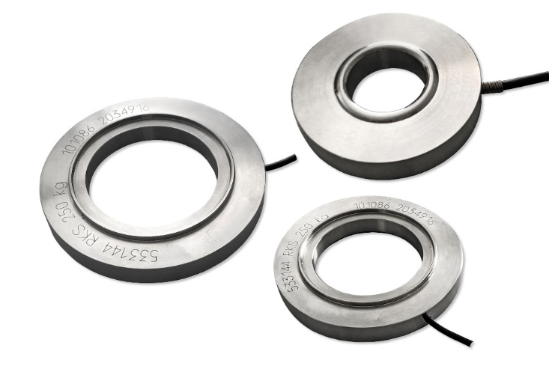
Caption: Inelta expands its portfolio of ring force sensors for different nominal loads to include units with galvanically isolated inputs for safety-critical applications

Image/s: | 3_ringkraftsensoren_2000px.jpg | Characters: | 1,893
File name: | 202402021_pm_ring-force-sensors.docx | Date: | 02-27-2024

About Inelta
Inelta Sensorsysteme GmbH & Co. KG with its headquarters in Taufkirchen near Munich has been developing, producing, and selling standard and customized sensor solutions for industrial applications for more than 25 years. Together with PIL Sensoren GmbH (Erlensee near Frankfurt/Main), an ultrasonic sensor system pioneer, and VYPRO s.r.o. (Trenčín, Slovakia), the company offers a wide range of products for measuring displacement and position as well as force, pressure and inclination measurement. The range includes force sensors, sensor signal amplifiers, pressure switches, capacitive sensors and ultrasonic sensors. Our portfolio is nicely rounded off with cable and connector assembly services.
Most of the group of companies’ customers are in industrial automation, mechanical engineering, hydraulics, medical technology as well as the aerospace industry. We especially focus on industry and customer-specific sensor solutions and are constantly expanding this focus with interdisciplinary know-how.

Contact:

Inelta Sensorsysteme GmbH & Co. KG
Reinhard Koch
Ludwig-Bölkow-Allee 22
82024 Taufkirchen
Tel.: 0 89 / 45 22 45-0
Fax: 0 89 / 45 22 45-744
E-Mail: reinhard.koch@inelta.de

Internet: www.inelta.de

