Press release

Customized torque sensors for robotics applications

Inelta Sensorsysteme offers a wide range of services, including the development and production of torque sensors with different calibrated nominal torques. With its development expertise and vertical range of manufacture, the sensor expert has specialized in the economical, quality-tested implementation of customer-specific solutions, even for small and medium batch sizes. On behalf of various well-known robotics manufacturers, Inelta manufactures compact static torque sensors according to customer specifications for precise torque measurement using strain gauges. The measuring sensors can be designed redundantly with two-channel, galvanically isolated signal transmission. Integrated interfaces allow the current torque to be queried directly. A resistor can be connected via an additional diagnostic channel using an optocoupler for targeted detuning of the bridge. The measuring sensitivity, relative deviations and reversal span result from the calibration requested by the customer. Static torque sensors are used to detect torques on measuring objects that are not moved when force is applied. This simplifies installation, as the sensor can be mechanically connected directly to the measurement object.

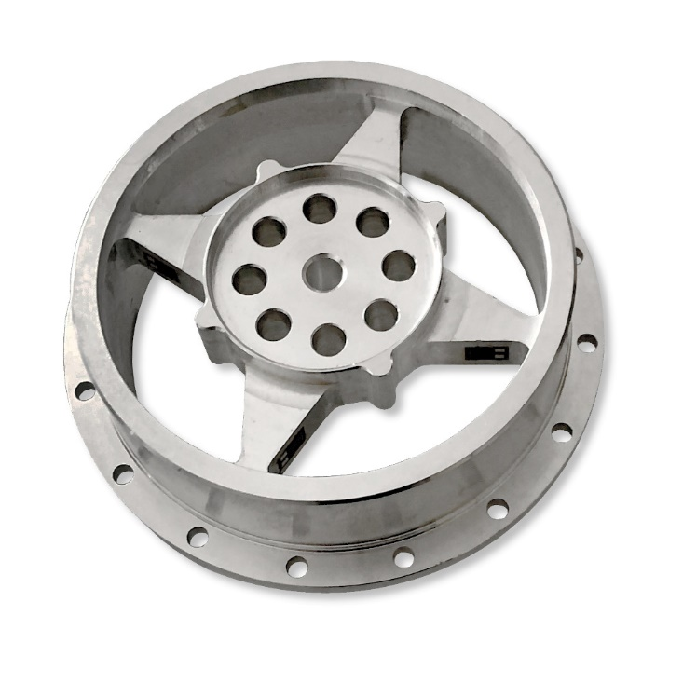
Caption: Customized static torque sensors from Inelta for precise torque measurement using strain gauges

Image/s: | drehmomentsensor_2000px.jpg | Characters: | 1,217
File name: | 202403002_pm_torque-sensors.docx | Date: | 04-03-2024

About Inelta
Inelta Sensorsysteme GmbH & Co. KG with its headquarters in Taufkirchen near Munich has been developing, producing, and selling standard and customized sensor solutions for industrial applications for more than 25 years. Together with PIL Sensoren GmbH (Erlensee near Frankfurt/Main), an ultrasonic sensor system pioneer, and VYPRO s.r.o. (Trenčín, Slovakia), the company offers a wide range of products for measuring displacement and position as well as force, pressure and inclination measurement. The range includes force sensors, sensor signal amplifiers, pressure switches, capacitive sensors and ultrasonic sensors. Our portfolio is nicely rounded off with cable and connector assembly services.
Most of the group of companies’ customers are in industrial automation, mechanical engineering, hydraulics, medical technology as well as the aerospace industry. We especially focus on industry and customer-specific sensor solutions and are constantly expanding this focus with interdisciplinary know-how.

Contact:

Inelta Sensorsysteme GmbH & Co. KG
Reinhard Koch
Ludwig-Bölkow-Allee 22
82024 Taufkirchen
Tel.: 0 89 / 45 22 45-0
Fax: 0 89 / 45 22 45-744
E-Mail: reinhard.koch@inelta.de

Internet: www.inelta.de

