Press Release

Oil-compatible LVDT displacement sensors for heavy-duty applications

For use in heavy machinery in oily environments, Inelta Sensorsysteme from Taufkirchen near Munich offers LVDT displacement sensors with a bypass for oil and grease. These inductive displacement sensors, which are available with or without an integrated return spring, are oil-compatible in accordance with SAE90 MIL 2105B. The measuring path of the measuring tip, which is manufactured in a robust stainless-steel housing, can be adapted to the specific application. The units achieve protection class IP68 and can be used in extended temperature ranges from -40°C to +80°C, depending on the version. The LVDT displacement sensors are characterized by their excellent repeatability. A 4..20mA output signal is used to output the measured values. The supply voltage is 24VDC. On request, Inelta also manufactures these LVDT sensors in customized versions with or without integrated amplifier, with different standard voltages or standard currents. As an alternative to the standard round housings, the sensor specialist also produces individual housing designs, for example in hexagonal format with the customer's preferred wrench widths. Such housings, which are screwed in or out via the head-side external thread and securely fixed in place with just a few turns of the wrench, are ideal for quickly replacing sensors in construction machinery, crane systems or other heavy-duty applications.

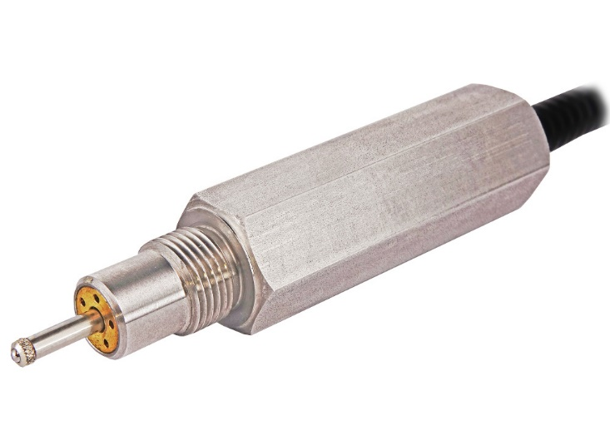
Caption: Inelta oil-compatible LVDT displacement sensors for heavy-duty applications, also available in customized housing shapes such as this SW32 hexagonal housing

Image/s: | lvdt-oelabscheider_2000px.jpg | Characters: | 1,414
File name: | 202406008_lvdt-sensor_en.docx | Date: | 06-27-2024
About Inelta
Based in Taufkirchen near Munich, Germany, Inelta Sensorsysteme GmbH & Co. KG has been developing, producing, and distributing standard and customized sensor solutions for various industrial applications for over 25 years. Together with PIL Sensoren GmbH (Erlensee, near Frankfurt, Germany), a pioneer in ultrasonic measurement, and VYPRO s.r.o. (Trenčín, Slovakia), Inelta offers a wide range of products for displacement and position measurement as well as for force, pressure, and tilt measurement. The range includes force sensors, sensor signal amplifiers, pressure switches, capacitive sensors, and ultrasonic sensors. Cable and connector configuration services complete the portfolio.
The group of companies supplies customers in industrial automation, mechanical engineering, hydraulics, medical technology, the aerospace sector, and many others. Industry-specific and tailor-made sensor solutions are a growing focus of activities enabled by interdisciplinary know-how. Inelta’s particular strength is the ability to flexibly respond to customer wishes.

Contact:  Inelta Sensorsysteme GmbH & Co. KG  Reinhard Koch  Ludwig-Bölkow-Allee 22  82024 Taufkirchen  Germany  Phone: +49 . 89 . 452 245-0  Fax: +49 . 89 . 452 245-744  Email: reinhard.koch@inelta.de  Internet: www.inelta.de | gii die Presse-Agentur GmbH  Christburger Str. 41  10405 Berlin  Germany  Phone: +49 . 30 . 538 965-0  Email: info@gii.de  Internet: www.gii.de

