Press release

Force sensor calibration according to European standard

Force sensors in applications that require high measuring accuracy should be recalibrated at certain intervals, as they lose precision due to ageing, temperature effects, cleaning procedures or other factors. Regular recalibration is also required as part of operational quality management in accordance with DIN EN ISO 9001. The sensor specialist Inelta has its own accredited test laboratory with Vypro (www.vypro.de), which is part of the group of companies. This enables Inelta to supply its force sensors not only with the required factory calibrations but also with a calibration certificate valid throughout Europe in accordance with ISO 376 and to carry out independent recalibrations. Calibration in accordance with ISO 376 with multiple preloads and different load levels allows the characteristic values for nominal force, hysteresis and repeatability to be determined precisely and the measurement uncertainty of the force transducer to be determined exactly for each load level. The Inelta calibration service includes both products manufactured in-house and third-party products in the measuring range from 0.1kN to 200kN. Tension force sensors, compression force sensors, ring force sensors, bending and shear bars as well as tension measuring straps, special force sensors and load measuring pins are calibrated. The traceability of the sensor calibration is ensured via the serial number. In addition, Vypro performs application-specific calibrations and offers a repair service for test specimens as well as an express service on request. The Vypro calibration laboratory is accredited in accordance with the European standard ISO/IEC 17025: 2017 by the accreditation body SNAS for the mechanical measurand force. Inquiries via https://www.inelta.de/en/service/calibration-service/ or +49 89/452245-0

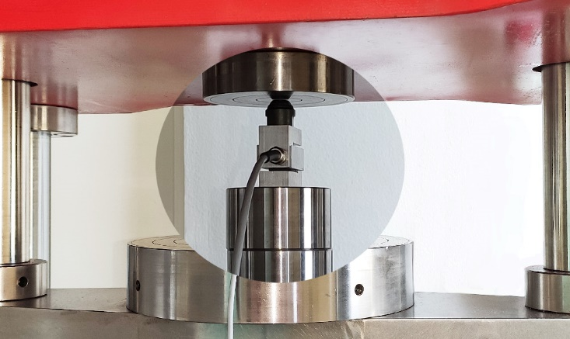
Caption: Vypro spol s.r.o., a member of the Inelta Group, performs force sensor calibrations in accordance with the European standard ISO 376

Image/s: | rekab_kraftsensor_2000.jpg | Characters: | 1,818
File name: | 202408010_pm_eu-sensor-kalib_en.docx | Date: | 08-05-2024

About Inelta
Inelta Sensorsysteme GmbH & Co. KG with its headquarters in Taufkirchen near Munich has been developing, producing, and selling standard and customized sensor solutions for industrial applications for more than 25 years. Together with PIL Sensoren GmbH (Erlensee near Frankfurt/Main), an ultrasonic sensor system pioneer, and VYPRO s.r.o. (Trenčín, Slovakia), the company offers a wide range of products for measuring displacement and position as well as force, pressure and inclination measurement. The range includes force sensors, sensor signal amplifiers, pressure switches, capacitive sensors and ultrasonic sensors. Our portfolio is nicely rounded off with cable and connector assembly services.
Most of the group of companies’ customers are in industrial automation, mechanical engineering, hydraulics, medical technology as well as the aerospace industry. We especially focus on industry and customer-specific sensor solutions and are constantly expanding this focus with interdisciplinary know-how.

Contact:

Inelta Sensorsysteme GmbH & Co. KG
Reinhard Koch
Esther Koller
Ludwig-Bölkow-Allee 22
82024 Taufkirchen
Germany
Phone: +49 . 89 . 452 245-0
Fax: +49 . 89 . 452 245-744
Email: reinhard.koch@inelta.de
esther.koller@inelta.de
Web: www.inelta.de

