Press release

Displacement sensor for hydraulics: Replaceable under full pressure

Inelta Sensorsysteme is a German leading developer and manufacturer of sensors for force, displacement and path length measurement. They also develop and produce displacement transducers and position switches for hydraulic applications. These differential transformers are mainly used in stationary hydraulics as well as in aircraft, vehicle and mobile hydraulics. The Inelta hydraulic series have internal measuring amplifiers for the current and voltage output and can withstand high pressures. Media contacting components withstand pressure peaks of up to 1200 bar. All hydraulic LVDT sensors measure in the µm range and operate hysteresis-free. Offset and gain can be adjusted using integrated electronics. A zero point setting is also provided. The LVDT-IHDL-M16 series for use in switch over and proportional valves is one of the displacement sensors adapted to hydraulic applications. A special feature is the removable sensor of the IHDL-M16 model, while the flange and pressure tube remain hydraulically sealed to the valve. Inelta manufactures this sensor series for pressures up to 350 bar and in special versions up to 500 bar. Sensor properties such as flange, measuring travel and supply voltage can be customized on request. With the LVDT-IHDZ displacement sensor, Inelta has an intermediate sensor with integrated measuring amplifier for proportional valves in its portfolio. The sensor with IP65 is designed for a maximum pressure of 350 bar. As a further solution specified for hydraulic applications, the sensor expert has developed precision position switches from the LVDT-IHDL series with an adjustable switching point. The inductive switches, which are suitable for pressure ranges up to 1000 bar and have a normally open / normally closed contact type, are available with an M16 female or M20 male thread and optionally with two adjustable switching outputs. In addition to its own product series, Inelta Sensorsysteme also produces customer-specific OEM versions or system solutions with integrated sensors. The manufacturer can also carry out numerous product adaptations, e.g. for connecting sensors to different bus systems or for extended temperature ranges up to +200°C.

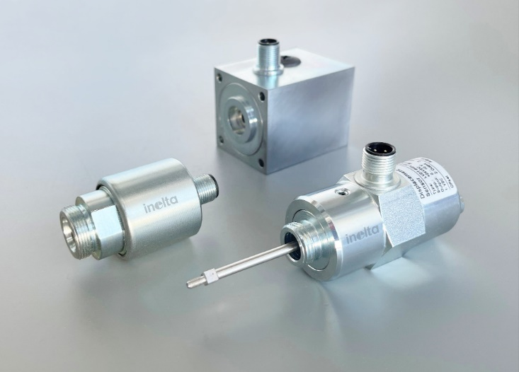
Caption: Displacement sensors of the LVDT-IHDL and LVDT-IHDZ series for hydraulic applications

Image/s: | sensoren_hydraulik_2000.jpg | Characters: | 2.202
File name: | 202410018_pm_lvdt-hydraulik_en.docx | Date: | 10-01-2024
Tags: | Inelta, sensor system, displacement sensor, LVDT, hydraulics, aircraft hydraulics, vehicle hydraulics, differential transformer, inductive position switch, displacement transducer, for hydraulic valves, mobile hydraulics, stationary hydraulics, for changeover valve, for proportional valve, LVDT-IHDL, LVDT-IHDZ

About Inelta
Inelta Sensorsysteme GmbH & Co. KG with its headquarters in Taufkirchen near Munich has been developing, producing, and selling standard and customized sensor solutions for industrial applications for more than 25 years. Together with PIL Sensoren GmbH (Erlensee near Frankfurt/Main), an ultrasonic sensor system pioneer, and VYPRO s.r.o. (Trenčín, Slovakia), the company offers a wide range of products for measuring displacement and position as well as force, pressure and inclination measurement. The range includes force sensors, sensor signal amplifiers, pressure switches, capacitive sensors and ultrasonic sensors. Our portfolio is nicely rounded off with cable and connector assembly services.
Most of the group of companies’ customers are in industrial automation, mechanical engineering, hydraulics, medical technology as well as the aerospace industry. We especially focus on industry and customer-specific sensor solutions and are constantly expanding this focus with interdisciplinary know-how.

Contact:

Inelta Sensorsysteme GmbH & Co. KG
Reinhard Koch
Esther Koller
Ludwig-Bölkow-Allee 22
82024 Taufkirchen
Germany
Phone: +49 89 / 45 22 45-0
Fax: +49 89 / 45 22 45-744
Email: reinhard.koch@inelta.de
esther.koller@inelta.de

Web: www.inelta.de

