Press Release

High-precision sensors and systems for medical technology

Very precise and reliable sensor technology is essential for the safe operation of medical devices that come into direct contact with patients. Inelta has been developing and producing high-precision sensors and systems in Germany for 25 years. The sensor expert has a broad portfolio of high-precision LVDT displacement sensors and strain gauge-based force sensors that are particularly suitable for use in medical equipment. In addition, the company develops and manufactures application-specific special solutions with appropriately adapted dimensions as well as complex sensor systems and advises manufacturers of medical devices on sensor customization and implementation. On request, Inelta also integrates the sensors into assemblies for medical devices. LVDT displacement sensors can be found, for example, in medical assistance systems such as surgical robots for precise positioning of instruments, lasers or probes within a few micrometers. The non-contact, inductive measuring principle ensures wear-free, long-lasting use. The sensor specialist has developed particularly small-sized sensor series. These include IZAL LVDT sensors with a diameter of just 4 mm and a 55 mm long housing. Customized force sensors are used in medical technology, for example, to measure the force with which the lens holder of laser-based vitrectomy systems fixes the eyeball. Inelta’s force transducers are also used in mammography compression devices.

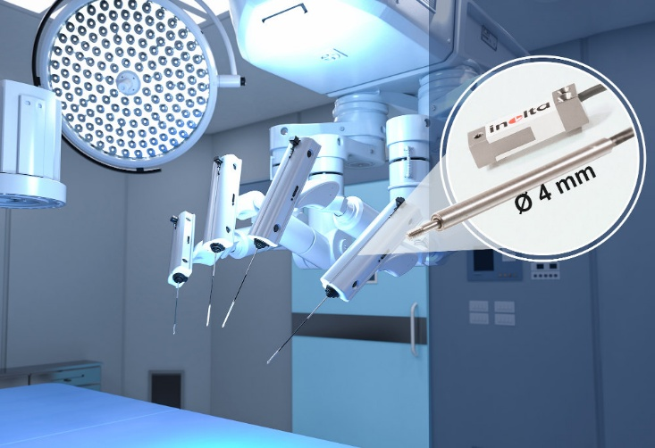
Caption: Inelta force and displacement sensors for medical technology: the F12 miniature bending beam sensor and the IZAL LVDT sensor featuring a 4-mm diameter

(image source: Inelta and iStock.com1364860543/PhonlaiPhoto)

The sensor specialist has developed particularly small force sensors such as the FS09 series, which, with dimensions of just 7 mm x 17 mm x 19 mm, requires very little space. The smallest bending beam force sensor models include FS12 force sensors, which weigh just 20 g and measure just 8 mm x 9 mm x 30 mm. They are used, for example, for tactile force measurements in surgical robot arms or for load tests on small components.

Image/s: | medtech-fs12-kraftsensor_2000_en.jpg | Characters: | 1875
File name: | 202412011_pm_sensors_medtech_en | Date: | 02-04-2025
Tags: | Inelta, sensor systems, sensor, LVDT, displacement sensor, transducers, bending beam, force sensor, medical technology, medical devices, surgical robots, mammography
About Inelta
Based in Taufkirchen near Munich, Germany, Inelta Sensorsysteme GmbH & Co. KG has been developing, producing, and distributing standard and customized sensor solutions for various industrial applications since 2000. Together with PIL Sensoren GmbH (Erlensee, Germany), a pioneer in ultrasonic measurement, and VYPRO s.r.o. (Trenčín, Slovakia), Inelta offers a wide range of products for displacement, position, force, pressure, and tilt measurement. The range includes force sensors, sensor signal amplifiers, pressure switches, capacitive sensors, and ultrasonic sensors. Cable and connector configuration services complete the portfolio.
The group of companies supplies customers in many industries, especially industrial automation, mechanical engineering, hydraulics, medical technology and the aerospace sector. Industry-specific and tailor-made sensor solutions are a particular focus, which is constantly being expanded with interdisciplinary expertise.
Contact:  Inelta Sensorsysteme GmbH & Co. KG  Esther Koller  Ludwig-Bölkow-Allee 22  82024 Taufkirchen  Germany  Phone: +49 . 89 . 452 245-0  Email: esther.koller@inelta.de  Internet: www.inelta.de |  | gii die Presse-Agentur GmbH  Christburger Str. 41  10405 Berlin  Germany  Tel.: +49 . 30 . 538 965-0  Email: info@gii.de  Internet: www.gii.de

