Press release

First digital LVDT displacement sensor with spring-loaded probe in the hydraulics sector

The pressure-tight installation of displacement sensors in the hydraulics sector can be very complex, as the core with core extension has to be installed first, then the pressure pipe has to be screwed in place and then the sensor has to be attached on top. To simplify the process, INELTA Sensorsysteme has developed and launched the first displacement sensor with digital electronics based on LVDT with probe and internal spring for hydraulic applications. This model series is called LVDT-IHDT and works with digital signal processing in a wide supply voltage range of 9...32 VDC. Both the measuring length and the output signals with current or voltage can be programmed on site using an external handheld device. An IO-Link interface is in preparation. Another special feature is the outstanding mechanical stability of the sensor. The LVDT-IHDT model is vibration-resistant up to 30 g, suitable for a temperature range of -25 °C to +85 °C and achieves protection class IP6K9K (ISO 20653). The high-precision digital displacement transducer is designed for pressure ranges up to 400 bar. Bypass holes in the bearing ensure that the hydraulic fluid can flow past the sensor. On request, sensor properties such as flange, supply voltage and pressure range can be customized.

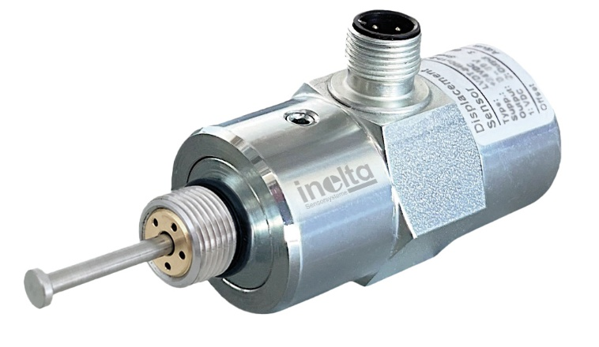
Caption: INELTA Sensorsysteme presents the first LVDT displacement sensor with digital signal processing, probe and internal spring for hydraulic applications

Image/s: | LVDT-IHDT-digital-taster_1000.jpg | Characters: | 1,277
File name: | 202504026_pm_lvdt-ihdt_en.docx | Date: | 04-28-2025
Tags: | Inelta, sensor system, LVDT, displacement sensor, LVDT-IHDT, hydraulics, hydraulic applications, displacement transducer

About Inelta
Inelta Sensorsysteme GmbH & Co. KG with its headquarters in Taufkirchen near Munich has been developing, producing, and selling standard and customized sensor solutions for industrial applications for more than 25 years. Together with PIL Sensoren GmbH (Erlensee near Frankfurt/Main), an ultrasonic sensor system pioneer, and VYPRO s.r.o. (Trenčín, Slovakia), the company offers a wide range of products for measuring displacement and position as well as force, pressure and inclination measurement. The range includes force sensors, sensor signal amplifiers, pressure switches, capacitive sensors and ultrasonic sensors. Our portfolio is nicely rounded off with cable and connector assembly services.
Most of the group of companies’ customers are in industrial automation, mechanical engineering, hydraulics, medical technology as well as the aerospace industry. We especially focus on industry and customer-specific sensor solutions and are constantly expanding this focus with interdisciplinary know-how.

Contact:

Inelta Sensorsysteme GmbH & Co. KG
Esther Koller
Ludwig-Bölkow-Allee 22
82024 Taufkirchen
Germany
Phone: +49 89 / 45 22 45-0
Fax: +49 89 / 45 22 45-744
Email: esther.koller@inelta.de

Web: www.inelta.de

