Press Release

RAFI SMART ENCODER:
Adaptive encoder with programmable haptic feedback

With the Smart Encoder, RAFI is expanding its portfolio to include a software-controlled, haptic rotary encoder that enables a completely new user experience. The encoder redefines the function of traditional rotary encoders by offering customizable, realistic haptic feedback for a wide variety of applications.

At the heart of the system is fully programmable haptics: click behavior, torque, end stops, and return to a center position can all be flexibly configured via software. This allows the tactile behavior to be precisely tailored to the specific function or user requirement.

Among other features, the Smart Encoder enables a variable number and intensity of detents, dynamic and context-dependent end stops, and active return to the center position, which creates a spring-like operating feel. In addition, dynamic torque control allows for real-time adjustment of resistance, ensuring particularly intuitive and precise user feedback.

Thanks to this flexibility, the Smart Encoder functions as an intelligent haptic interface that actively interacts with the user. The result is intuitive operation, greater operational safety, and a significant reduction in operating errors.

As a standardized platform solution, the Smart Encoder can be used in a wide range of applications, from industry and mechanical engineering to medical technology and agricultural and construction machinery. Developers and manufacturers benefit from a uniform, flexibly adaptable solution for a wide variety of application scenarios.

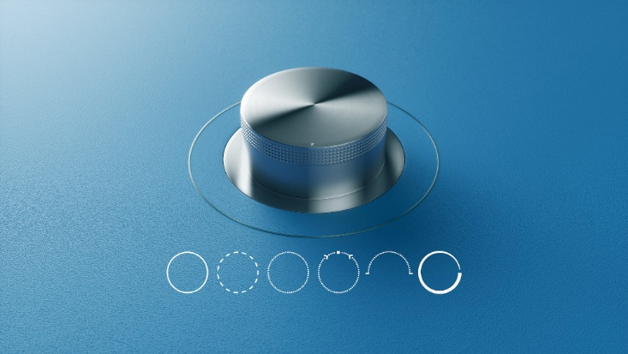

Caption 1: The flexibly programmable SMART ENCODER from RAFI can be optimally adapted to specific application requirements in terms of detent behavior, torque, and angle.

Image source: RAFI



Caption 2: The SMART ENCODER from RAFI offers individually customizable, realistic haptic feedback for a wide variety of applications.

Image source: RAFI

Image/s: | smartencoder_funktionen_2000.jpg  smart_encoder_1_2000.jpg | Characters: | 1,524
File name: | 202604032_PM2_smart-encoder.docx | Date: | 07-30-2026
Tags: | RAFI, Smart Encoder, adaptive encoder, programmable haptic feedback, rotary encoder, haptic feedback, tactile behavior, torque control, real-time adjustment, user feedback, haptic interface, industry, mechanical engineering, medical technology, agricultural machinery, construction machinery, detent behavior, programmable haptics

About the RAFI Group
Founded in 1900, RAFI today develops and produces electromechanical components and systems for human-machine interaction. The range of products includes key switches, switches, touchscreens, control systems, and electronic assemblies. RAFI products are employed in many industries including automation, medical technology, machine and plant engineering, road and railway vehicles, household appliances, and telecommunication. The RAFI Group operates internationally with more than 2,000 employees at sites in Germany, Europe, China, and the USA. Its headquarters are in Berg, Germany.

Contact:  RAFI GmbH & Co. KG  Fred Nemitz  Head of Corporate Marketing  Ravensburger Straße 128-134  88276 Berg  Germany  Phone: +49 160 92048569  Email: fred.nemitz@rafi-group.com  Web: www.rafi-group.com |  | gii die Presse-Agentur GmbH  Christburger Str. 41  10405 Berlin, Germany  Phone: +49 30 53 89 65-0  Email: info@gii.de  Web: www.gii.de

