Press Release

Mathis Menzel appointed EASA chairman

Mathis Menzel, CEO of Menzel Elektromotoren, is the new chairman of the drive technology association EASA. As the first German to hold this position, he has placed his term of office under the motto “Stronger together”.

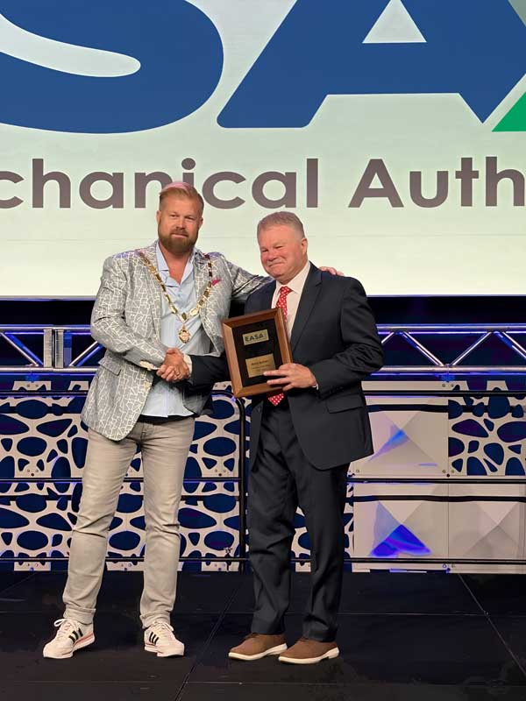
Caption: At the EASA convention in Orlando, Mathis Menzel receives the certificate of appointment as chairman of the drive technology association from his predecessor, Barry S. Bullard

Mathis Menzel has been appointed the new chairman of EASA (Electrical Apparatus Service Association), an international association of companies in the electric motor and drive technology sector. He will chair the organization for one year and has placed his term under the motto “Stronger together”.
The official inauguration took place at EASA’s annual convention on 16 June 2026 in Orlando, Florida. In his opening speech, Menzel emphasized the unique cooperative culture in the drive technology industry. “EASA is a community where competitors help each other, where experience is shared generously and where people genuinely want each other to succeed.” Considering technological developments such as artificial intelligence and digitalization as well as economic challenges including rising costs and supply chain disruptions, Menzel stressed that education, innovation, craftsmanship and cross-border collaboration were more important than ever.
Mathis Menzel is the third-generation CEO of Menzel Elektromotoren. He has expanded the German company internationally in recent decades and spearheaded the construction of a new state-of-the-art motor factory on the outskirts of Berlin to meet the growing demand for large, customized electric motors.
Among EASA chairmen, Menzel is one of the few Europeans and the first non-native English speaker. He has previously served in various leadership roles in the European EASA chapter and on the international board of directors.

More about EASA and Menzel’s work in the association: https://www.menzel-motors.com/networking/

Image/s: | mathis_menzel__barry_s_bullard__easa_2026_2 |  | Characters: | 1476
File name: | 202606002_pm_easa_chairman_mathis_menzel_en |  | Date: | 06-17-2026
Tags: | Menzel Elektromotoren, EASA, Mathis Menzel, Barry S. Bullard, drive technology, customized electric motors
About Menzel Elektromotoren
Menzel Elektromotoren GmbH has been manufacturing and distributing electric motors since 1927. The German family-run company based in Hennigsdorf near Berlin specializes in the delivery of large electric motors, including special models, within the shortest time possible. The product range comprises high and low voltage motors, DC motors, transformers, and frequency inverters. Services include motor production up to and beyond 25 MW and short-term adaptation of stock motors to application-specific requirements. In order to ensure short delivery times, Menzel maintains a large inventory with over 20,000 motors up to 15 MW. Qualified engineering, experienced staff, and state-of-the-art production and testing facilities help the manufacturer provide excellent reliability. Menzel operates subsidiaries in Sweden, the UK, France and Italy and cooperates with numerous partners worldwide.
Contact:  Menzel Elektromotoren GmbH  Anja Leipold  Corporate Communications  Am Alten Walzwerk 2  16761 Hennigsdorf  Germany  Phone: +49 30 349 922-0  Email: info@menzel-motors.com  Internet: www.menzel-motors.com |  | gii die Presse-Agentur GmbH  Christburger Str. 41  10405 Berlin  Germany  Phone: +49 30 538 965-0  Email: info@gii.de  Internet: www.gii.de

