Press Release
Calibration of Force Sensors According to ISO/IEC 17025:2017:
The Foundation for Globally Comparable Measurement Results

Reliable measurement data is a key prerequisite for stable processes and consistently high product quality in industry. The calibration of sensors, especially force sensors, plays a crucial role in this regard. This is because even high-quality force sensors are subject to external influences during operation, such as temperature or humidity. Aging processes can also impair measurement accuracy.

For companies with a certified quality management system according to DIN EN ISO 9001, regular recalibration is therefore mandatory. Against this backdrop, calibration in accordance with the European standard ISO/IEC 17025:2017 is relevant. It ensures that measurement results are traceable, reproducible, and comparable worldwide, a decisive factor for companies with international supply chains and high-quality requirements.

As part of the INELTA Group, VYPRO operates its own accredited testing laboratory and offers calibration services for force transducers of various designs, manufacturer-independent and compliant with ISO/IEC 17025:2017. Users benefit from internationally recognized calibration results that provide a solid foundation for audits and certification processes.

The range of services includes, among other things, calibrations of tensile and compressive force sensors, ring force sensors, bending and shear bar sensors, tensile test slats, and custom force sensors.

ISO and in-house calibrations are performed up to 200 kN in both tensile and compressive directions. The service offering is complemented by technical inspections and, if necessary, repairs to the test specimen. Time-sensitive calibrations can also be performed upon request. An internationally recognized calibration certificate confirms successful calibration.

This offers clear advantages for companies: measurement deviations are detected early, processes can be stabilized over the long term, and regulatory requirements are reliably met. In addition, the comparability of measurement results across locations and countries is ensured, a key success factor in globally networked production environments.

Please send inquiries to kalibrierung@inelta.de

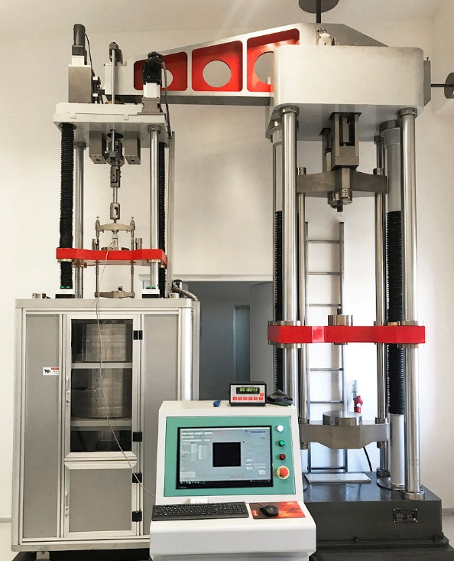
Caption: Measurement setup in the VYPRO calibration laboratory: precise calibration for reliable sensor readings and maximum technical safety.

(Image Source: Vypro)

Image/s: | kalibrieranlage-vypro_2000.jpg | Characters: | 2,144
File name: | 2026077_PM2_calibration_vypro_en.docx | Date: | 05-07-2026
Tags | VYPRO, force sensor calibration, accredited calibrations, internationally recognized certificate, ISO/IEC 17025:2017

About VYPRO
VYPRO, s. r. o., headquartered in Trenčín, Slovakia, is a system partner specializing in the manufacture of electronic and mechanical components, assemblies, and complete devices. Drawing on many years of experience in sensor manufacturing, the company also offers comprehensive services in the areas of technical testing and calibration. Both the manufacturing machines used and the measuring and calibration equipment are always state-of-the-art.
A key factor in VYPRO’s success is its qualified and dedicated staff, who work according to precise process specifications and strict quality standards. Particularly noteworthy is the careful handcrafted production of sophisticated mechatronic components, which allows even small batches to be manufactured economically and with high precision, especially when the production of special tools is not practical. The range of services is complemented by the personal and expert advice of the technical sales team, which supports customers in implementing their individual requirements.
Contact:  INELTA Sensorsysteme GmbH & Co. KG  Bettina Redepenning  Ludwig-Bölkow-Allee 22  82024 Taufkirchen  Tel.: +49 89 45 22 45 0  E-Mail: bettina.redepenning@inelta.de  E-Mail: kalibrierung@inelta.de  Internet: Akkreditierter Kalibrierservice | VYPRO | gii die Presse-Agentur GmbH  Christburger Str. 41  10405 Berlin  Tel.: 030 / 538 965-0  E-Mail: info@gii.de  Internet: www.gii.de

