Press Release

Large Ex ec motor for refinery in two weeks

Menzel Elektromotoren delivered an explosion-proof pump motor rated 1,686 kW for Gas Ex Zone 2 to an English refinery in just two weeks. Thanks to extensive stock and in-house manufacturing, the family-run company prevented a production shutdown that could have lasted months.

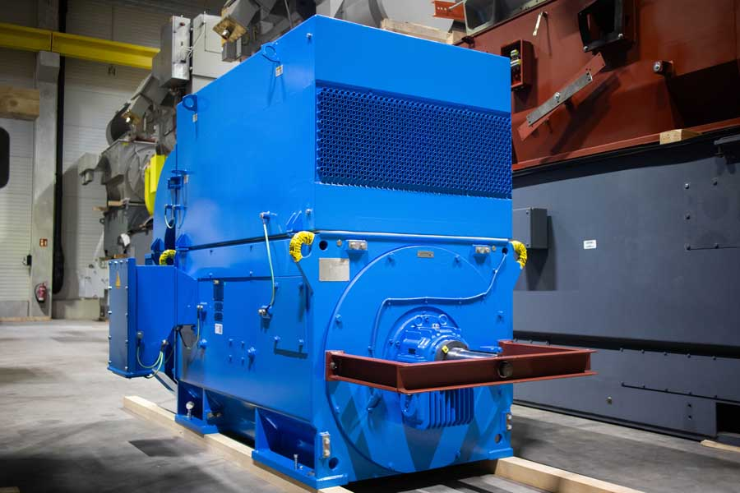
Caption: Large industrial motors – explosion-protected ones in particular – typically carry lead times of six months or more. Menzel Elektromotoren delivered a new Ex ec pump motor to a refinery in just two weeks, preventing costly production losses.

Menzel Elektromotoren has supplied an English refinery with an urgently needed replacement for a failed main pump motor in a Gas Explosion Zone 2 hazardous area. The motor manufacturer routinely handles emergency orders. Customers who would otherwise face months of production downtime avoid major financial losses as a result. In the present case, just one day separated initial inquiry, quote and order. Two calendar weeks later, Menzel shipped the finished motor.

The Berlin-based manufacturer is certified for producing large three-phase motors to ignition protection type Ex ec (“increased safety”). It maintains a large inventory of motors and accessories and can implement many designs, equipment options and cooling types quickly in-house.

The squirrel-cage motor built for the refinery is rated for an output of 1,686 kW at 3,300 V, delivering a speed of 2,964 rpm and a torque of 5,432 Nm at the rated operating point. Menzel’s explosion protection specialists labeled the motor II 3G Ex ec IIB T3 Gc. The Ex ec protection type ensures that the motor generates no ignitable sparks during normal operation and surface temperatures remain within safe limits.

The MEBKSL-type motor has a shaft height of 500 mm and weighs 6.6 t. It features protection class IP55 and an air-to-air heat exchanger (cooling type IC 611). Because the oil industry application required reverse rotation, the manufacturer reversed the fan blades – the most time-consuming step in the entire project. Beyond that, Menzel adapted the motor in every mechanical and electrical detail so the customer could install and commission it as a direct drop-in replacement, with no modifications required either to the motor or to the existing installation. The proven MEBKSL motor series design ensures reliable, long-lasting and efficient operation.

More about explosion protection and ATEX certification for electric motors in gas and dust hazardous areas: https://www.menzel-motors.com/ex-na/

Image/s: | ex_ec_charge_pump_motor_h13339 | Characters: | 1820
File name: | 20260818-Menzel-PM-EN-Ex-ec-pump-motor | Date: | 08-18-2026
Tags: | pump motor, drop-in replacement, ATEX, explosion protection, Gas Ex, Ex ec, oil industry, refinery | gii ID: | 26255
About Menzel Elektromotoren
Menzel Elektromotoren GmbH has been manufacturing and distributing electric motors since 1927. The German family-run company based in Hennigsdorf near Berlin specializes in the delivery of large electric motors, including special models, within the shortest time possible. The product range comprises high and low voltage motors, DC motors, transformers, and frequency inverters. Services include motor production up to and beyond 25 MW and short-term adaptation of stock motors to application-specific requirements. In order to ensure short delivery times, Menzel maintains a large inventory with over 20,000 motors up to 15 MW. Qualified engineering, experienced staff, and state-of-the-art production and testing facilities help the manufacturer provide excellent reliability. Menzel operates subsidiaries in Sweden, the UK, France and Italy and cooperates with numerous partners worldwide.
Contact:  Menzel Elektromotoren GmbH  Anja Leipold  Corporate Communications  Am Alten Walzwerk 2  16761 Hennigsdorf  Germany  Phone: +49 30 349 922-0  Email: info@menzel-motors.com  Internet: www.menzel-motors.com |  | gii die Presse-Agentur GmbH  Christburger Str. 41  10405 Berlin  Germany  Phone: +49 30 538 965-0  Email: info@gii.de  Internet: www.gii.de

