Press release

INELTA Sensorsysteme celebrates its 25th anniversary

On its anniversary, INELTA Sensorsysteme looks back on 25 years of successful company history. Since its foundation in 2000, the company has developed into a recognised specialist for customer-specific sensor solutions and standard sensors for demanding industrial applications.
Over the past two and a half decades, INELTA Sensorsysteme has produced a wide range of displacement and force sensors, as well as inclination sensors, measuring amplifiers, pressure switches and motor potentiometers in various batch sizes. In addition, INELTA Sensorsysteme has been developing and producing sensors, entire assemblies and sensor systems in the field of medical technology since 2012, and complete devices since 2022. Furthermore, over the last ten years, the sensor specialist has established itself as a reliable partner for renowned customers in the aerospace industry.

The company has grown steadily and laid the foundation stone for its current headquarters in Taufkirchen in 2017. The following year, it celebrated its move into the state-of-the-art facility. INELTA has continuously invested in the expansion of its production areas and in modern manufacturing technologies.

The INELTA team consists of highly specialised engineers and technicians and is distinguished by its comprehensive application knowledge in medical technology, aerospace, hydraulics, automation, the food industry and mechanical engineering. The sensor manufacturer has its own research and development department. The company's high-tech equipment includes specialised measurement and testing laboratories for environmental testing, climate and temperature testing, an EMC laboratory for standard-compliant testing with certified equipment, mechanical and electrical long-term testing, vibration and oscillation analysis, endurance tests and outdoor measurements.
“From the very beginning, our motivation has been to develop and manufacture high-precision sensor technology at the highest level while responding flexibly to individual requirements. The past 25 years have confirmed our vision and motivate us to continue our pioneering work in sensor development,” says Dr. Jochen Heimann, CEO and founder of INELTA Sensorsysteme.

All signs point to growth for INELTA in the coming years. The company plans to develop new products and technologies and expand existing business areas. With the continuous expansion of its high-tech infrastructure and expertise in tailor-made solutions, the manufacturer aims to continue offering its customers decisive competitive advantages in the future.

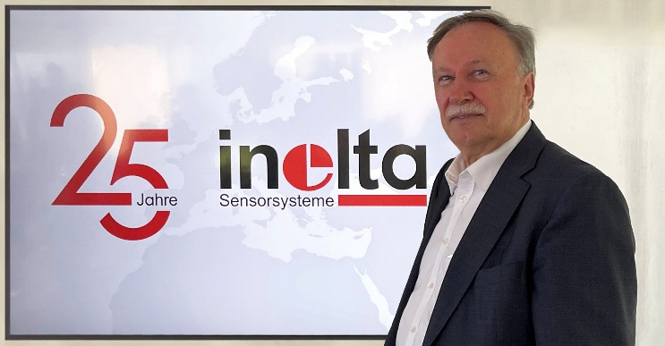
Caption: 25th company anniversary: Dr. Jochen Heimann, CEO and founder of INELTA Sensorsysteme

Image/s: | j_heimann_25-jahre.jpg | Characters: | 2,564
File name: | 25_years_inelta_en.docx | Date: | 11-13-2025
Tags: | Inelta, sensor systems, sensor, displacement sensor, force sensor, inclination sensor, measuring amplifier, pressure switch, motor potentiometer, displacement sensors, displacement transducers, force sensors, LVDT, assemblies, medical technology, aviation, hydraulics, sensor technology, medical devices, device manufacturers, sensors, 25 years, company anniversary, Taufkirchen

About Inelta Sensorsysteme
Inelta Sensorsysteme GmbH & Co. KG with its headquarters in Taufkirchen near Munich has been developing, producing, and selling standard and customized sensor solutions for industrial applications for 25 years. Together with PIL Sensoren GmbH (Erlensee near Frankfurt/Main), an ultrasonic sensor system pioneer, and VYPRO s.r.o. (Trenčín, Slovakia), the company offers a wide range of products for measuring displacement and position as well as force, pressure and inclination measurement. The range includes displacement sensors, force sensors, signal conditioner, inclination sensors, pressure switches and ultrasonic sensors. Our portfolio is nicely rounded off with cable and connector assembly services.
Most of the group of companies’ customers are in industrial automation, mechanical engineering, hydraulics, medical technology as well as the aerospace industry. We especially focus on industry and customer-specific sensor solutions and are constantly expanding this focus with interdisciplinary know-how.

Contact:

Inelta Sensorsysteme GmbH & Co. KG
Esther Koller
Ludwig-Bölkow-Allee 22
82024 Taufkirchen
Germany
Phone: +49 89 / 45 22 45-0
Fax: +49 89 / 45 22 45-744
Email: esther.koller@inelta.de

Web: www.inelta.de

