Press Release

GOSSEN Introduces New MAVOBASE-LUX Model in the Field of Light Measurement Technology

[Nuremberg, July 28, 2026] – With the new MAVOBASE line, GOSSEN Photo and Light Measurement Technology is launching a series of measuring instruments that combines precise measurement technology, ease of use, and an attractive price-performance ratio. The series is aimed at users in industry, trade, and quality assurance who require reliable measurement results without having to resort to costly high-end solutions.

The MAVOBASE LUX is an illuminance meter compliant with DIN 5032-7 Class C, designed for standard-compliant measurements in workplaces, production environments, and during maintenance and inspection tasks. Equipped with useful measurement functions such as relative measurement to correct the measured value in the presence of stray light or daylight and MIN/MAX/AVG functionality, it offers the necessary flexibility for a wide range of applications.

The device features a robust design, compact dimensions, and intuitive operation. The new model focuses on practical handling and reproducible measurement results in daily use. In addition, DAkkS and factory calibrations are offered by our accredited lighting laboratory. With the MAVOBASE series, GOSSEN is expanding its portfolio to include a cost-effective solution for professional light measurements, specifically bridging the gap between entry-level and high-end measuring instruments.

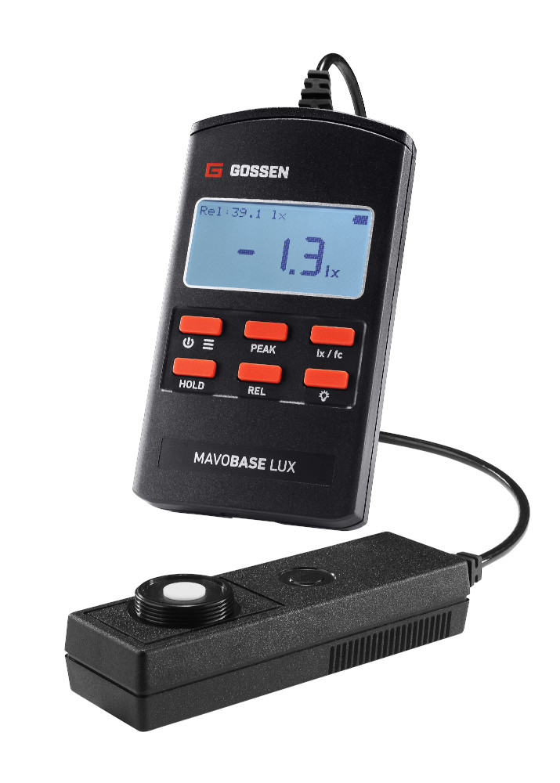
Caption: With the measuring instrument MAVOBASE LUX, GOSSEN offers an economical solution for standard-compliant light measurement in workplaces and production environments.

(Image source: GOSSEN Foto- und Lichtmesstechnik)

Image/s: | MAVOBASE_LUX_2000.jpg | Characters: | 1,331
File name: | 26205-GMC-PM2-mavobase-lux_en.docx | Date: | 07-28-2026
Tags: | GOSSEN, MAVOBASE, photometry, light meter, illuminance meter, illuminance measurement, DIN 5032-7 Class C, quality assurance, DAkkS calibration, industry, trade, precision measurement technology, light measurement

About GOSSEN
GOSSEN Foto- und Lichtmesstechnik GmbH specializes in light measurement and has decades of experience in this field. Continuous innovation is the company’s response to rapidly changing technologies, regulations, and markets. The outstanding quality and reliability of its products are ensured by highly qualified employees, manufacturing in Germany, a certified quality management system, and an accredited photometric laboratory.
GOSSEN is part of the global GMC Instruments GmbH, headquartered in Nuremberg. The group combines local manufacturing with international reach and delivers industry-leading solutions in electrical test and measurement equipment, energy monitoring, and photometry. Customers across a wide range of industries benefit from a comprehensive portfolio that includes calibration services and professional training.

Contact:
GOSSEN Foto- und Lichtmesstechnik GmbH
Andreas Stollberg
Product and Business Development Management
Lina-Ammon-Straße 22
90471 Nuremberg
Phone: +49 911 800 621-0
Email: andreas.stollberg@gossen-photo.de
gossen-photo.de

