Press Release

Smart RAFI control units with up to six actuators
XL control boxes with IO-Link interface

At SPS 2026, which is taking place from November 24 to 26, RAFI will focus on its slimline control units for automating decentralized industrial environments. At Booth 394 in Hall 7, visitors will be able to explore the versatile E-BOX product family, including the XL version with three to six actuators.
RAFI offers the E-BOX XL in four modular versions that can be individually equipped with RAFIX 22 FS⁺ actuators, as well as 17 preconfigured versions with IO-Link connectivity. Available with up to six illuminated pushbuttons, an optional emergency stop, or a configuration featuring a selector switch and an audible signaling device, these control boxes connect easily to an IO-Link master via Plug&Play. The bus-independent protocol enables digital control, function monitoring, and bidirectional transmission of actuator and sensor data from the field. Just one port on the IO-Link master is needed to connect six illuminated pushbuttons. The actuators can be configured via IO-Link for various functions, including RGB illumination, flashing modes, night mode, volume, and sound modes.
The IO-Link interface complies with version 1.1.4 and uses a four-pin, A-coded M12 connector. Additional interfaces include an M12 emergency stop connector and an optional additional M12 bushing for connecting further sensors and actuators. All versions of the E-BOX XL IO-Link can withstand temperatures ranging from -30 °C to +60 °C, meet the IP65 degree of protection, and are CE marked and UL certified. The slim housing width characteristic of the entire product family allows for direct mounting on 40 mm aluminum profiles using screws in any assembling axis. The FLEXLAB labeling system is available for custom marking of illuminated pushbuttons.

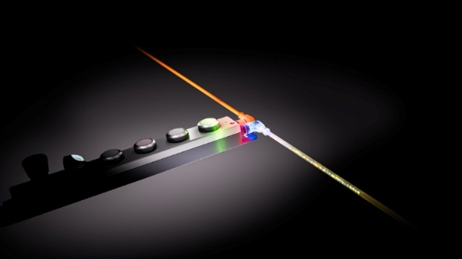

Caption 1: The E-BOX IO-Link enables up to six control components to be connected to existing fieldbus or Ethernet networks.

Source: RAFI

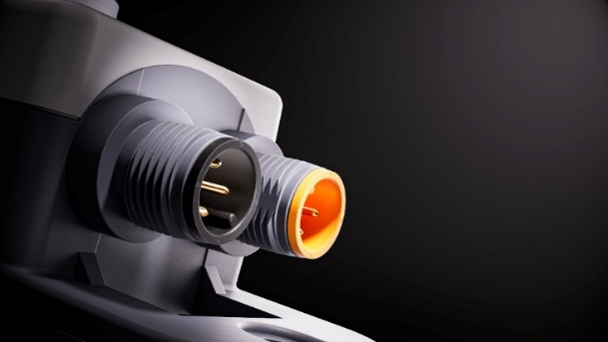

Caption 2: The E-BOX makes it easy to network decentralized control components via IO-Link using Plug&Play.

Source: RAFI

Image/s: | e-box_iolink_2000.jpg  e-box_io-anschluesse_2000.jpg | Characters: | 1,750
File name: | 26321-RAFI-PM1-ebox-xl-io-link_en.docx | Date: | 10-20-2026
Tags: | RAFI, control units, IO-Link interface, SPS 2026, E-BOX IO-Link, control boxes, RAFIX 22 FS+, M12 connector, FLEXLAB

About the RAFI Group

Founded in 1900, RAFI today develops and manufactures electromechanical components and systems for human-machine interaction. Its product range includes switches and key switches, touchscreens, control systems, and electronic assemblies. RAFI products are used in automation, medical technology, mechanical and plant engineering, road and rail vehicles, household appliances, and telecommunications. The RAFI Group operates internationally, with over 2,000 employees at sites in Germany, Europe, China, and the USA. The headquarters of the RAFI Group are located in Berg near Ravensburg.

Contact:  RAFI GmbH & Co. KG  Fred Nemitz  Corporate Communications  Ravensburger Strasse 128–134  88276 Berg, Germany  Phone: 0160 92048569  Email: fred.nemitz@rafi-group.com  Web: www.rafi-group.com |  | gii die Presse-Agentur GmbH  Christburger Str. 41  10405 Berlin  Phone: 030 53 89 65-0  Email: info@gii.de  Web: www.gii.de

