Exhibitor debut at leading tradeshow for transportation technology
Conta-Clip shows new rail-certified cable entries at InnoTrans 2026

Conta-Clip makes its InnoTrans debut, showcasing new rail-certified cable entry systems. KDS-DE-Rail and KDS-DEG-Rail comply with EN 61373 and HL3 and combine fast, tool-free installation with IP66 protection.

InnoTrans, the international leading trade fair for transportation technology, celebrates its 30th anniversary in 2026. The Berlin show runs from September 22 to 25 with a focus on safety and effective fire protection in modern rail transport.

Passenger safety rightfully comes first, but speed is equally important for success. Conta-Clip’s cable entry systems for rail applications deliver both. The new KDS-Rail systems ensure compliance and protection for passengers and operators: KDS-DE-Rail and KDS-DEG-Rail are tested to EN 61373 and carry the HL3 approval. They also save much installation time – both in initial setups and when adding or replacing cables.

InnoTrans visitors can see these advantages firsthand at the Conta-Clip booth. The KDS cable management system is part of a comprehensive modular portfolio for routing and feeding cables with and without connectors. Key features include high flexibility, tool-free installation from outside to inside or inside to outside, and an IP66 protection rating. The system enables smart cable routing in control cabinets, machines or enclosures and adapts to changing requirements at any time without removing the frame.

Conta-Clip at InnoTrans 2026: Hall 12, Booth 77

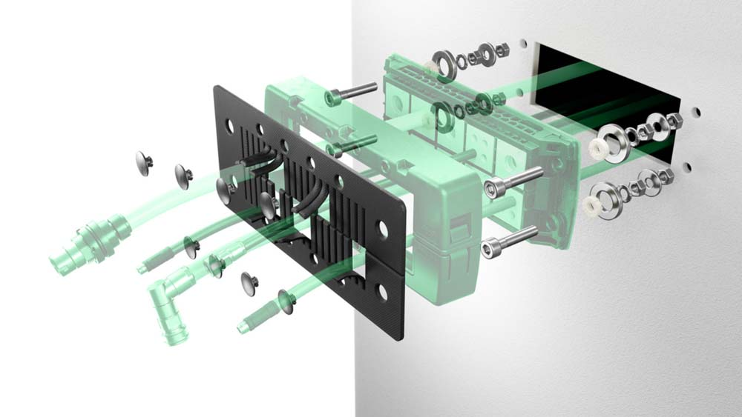
Caption: A safe choice: the new KDS-RAIL fire protection set

Image/s: | SET-Explosion | Characters: | 1176
File name: | Conta-Clip-KDS-InnoTrans-PM-EN-2026-08-19 | Date: | 08-19-2026
Tags: | InnoTrans, Berlin, rail transport, transportation technology, rail-certified, HL3 approval, cable management, cable entry, cable entries, safety, fire protection | gii ID: | 26257
About CONTA-CLIP
CONTA-CLIP is one of Europe’s leading manufacturers of electrical and electronic connection elements and cable management solutions. Based in Hövelhof, Germany, the medium-sized, family-run company has been producing electric and electronic connection systems for the process and automation industries since 1978. CONTA-CLIP supplies all industry sectors, focusing on railroad industries, shipbuilding, building automation, conveyor technology, machine and plant engineering and construction, instrumentation and control technology, control panel manufacturing, transformer manufacturing, and environmental technology. The company consists of many specialized branches: CONTA-CONNECT for electric connection technology, CONTA-CABLE for cable management systems, CONTA-ELECTRONICS for electronics and CONTA-CON for PCB edge connectors. Additionally, CONTA-CLIP provides services such as customizing housings and mounting rails, labeling and supplying user-specific electronic components.
Contact:  CONTA-CLIP  Verbindungstechnik GmbH  Christian Quade  Otto-Hahn-Str. 7  33161 Hövelhof  Germany  Phone: +49 5257 9833-172  Email: christian.quade@conta-clip.de  Internet: www.conta-clip.com |  | gii die Presse-Agentur GmbH  Christburger Str. 41  10405 Berlin  Germany  Phone: +49 30 538 965-0  Email: info@gii.de  Internet: www.gii.de

