Press Release

Robust USB 3.0 and RJ45 feedthroughs for integrated and standalone setups

The RAFI RAMO range includes robust USB 3.0 and RJ45 feedthroughs for front panel installation or standalone setups, in addition to switches and signal lamps with M12 plug terminals. The RAMO F feedthroughs feature an IP65 degree of protection when the protective cap is closed. RAMO EDGE 90° mounting angles allow for remote mounting of individual feedthroughs and other RAMO components on vertical surfaces or on 40-mm profile rails. RAFI especially designed all RAMO 22 and 30 components for individual housing-free mounting at remote locations. Featuring single-part, fully enclosed mono-housings, the feedthroughs can be installed in 22.3 mm or 30.3 mm mounting holes without an additional housing, just like the series' pushbuttons, emergency stop switches, selector switches, keylock switches, and LED signal lamps. RAMO 22 components feature black plastic front rings. RAMO 30 versions have a flat stainless-steel bezel.

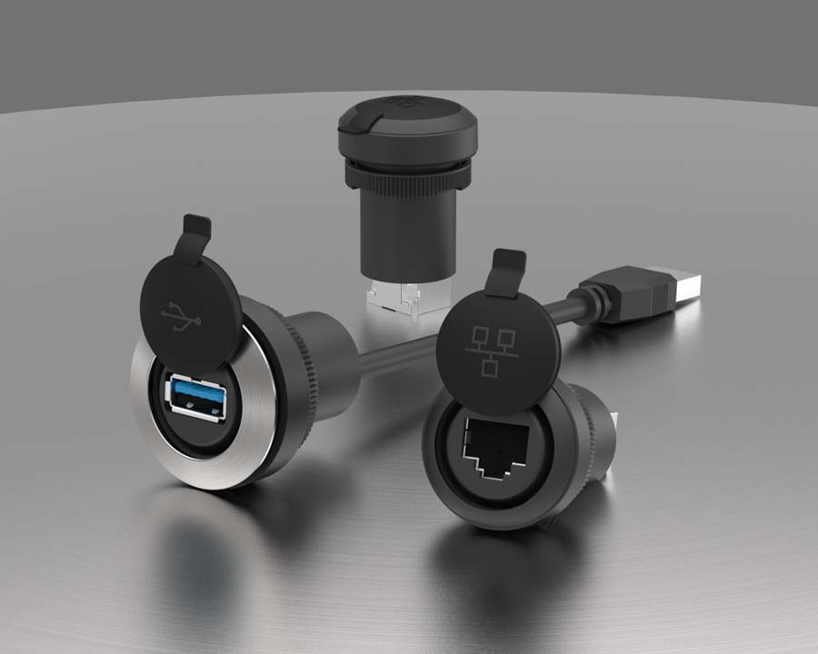
Caption: The RAMO range comprises USB 3.0 and RJ45 feedthroughs for offset installation as well as pushbuttons, signal lamps, emergency stop switches, selector switches, and keylock switches with M12 plug terminals

Image/s: | RAMO_F_USB-RJ45 | Characters: | 928
File name: | 201909023_pm_ramo_f_feedthrough_en | Date: | 01-09-2020
About the RAFI group
Founded in 1900, RAFI today develops and produces electromechanical components and systems for human–machine interaction. The range of products includes pushbuttons, switches, touchscreens, control systems and electronic assemblies. RAFI products are employed in many industries including automation, medical technology, machine and plant engineering, road and railway vehicles, household appliances and telecommunication. The RAFI group operates internationally with approx. 2,500 employees at sites in Germany, Europe, China and the USA. Its headquarters are in Berg, Germany.

Contact:  RAFI GmbH & Co. KG  Artur Krug  Ravensburger Str. 128-134  88276 Berg  Germany  Phone: +49 . 751 . 891 307  Email: artur.krug@rafi.de  Internet: www.rafi.de | gii die Presse-Agentur GmbH  Immanuelkirchstr. 12  10405 Berlin  Germany  Phone: +49 . 30 . 538 9650  Email: info@gii.de  Internet: www.gii.de

