Press Release

Screwless cable entry system

CONTA-CLIP further expands its KES cable management program, adding the KES-E version for screwless mounting. The cable entry plates enable quick and safe feed-in of non-assembled cables and conduits into control cabinets and machine enclosures, without the need for cable glands. The new KES-E cable entry plate can be installed without tools thanks to the all-round profile gasket. The plate is simply pressed into a 36 mm x 112 mm standard opening in a cabinet or housing wall. The profile gasket's elastic inner sealing lip tightly curves around the opening inside the housing, ensuring a tight and vibration-proof hold. The initial KES-E launch comprises nine variants in “A” and “B” versions for cables and pneumatic hoses with diameters from 1 mm to 16 mm. The cable entry plates are suitable for wall thicknesses “A” from 1.5 mm to 2.5 mm or “B” from 2.5 mm to 4 mm. Depending on the design, these plates hold up to 48 cables or conduits, thus allowing for extraordinarily high packing densities. The cable entry system provides IP54 protection against dust and splashing water ingress. Its smooth surfaces, rounded corners, and ECOLAB-certified material resistance to industrial cleaning agents ensure the necessary hygienic properties for use in the food or pharmaceutical industries and suitability for ambient temperatures from -40 °C to +90 °C.

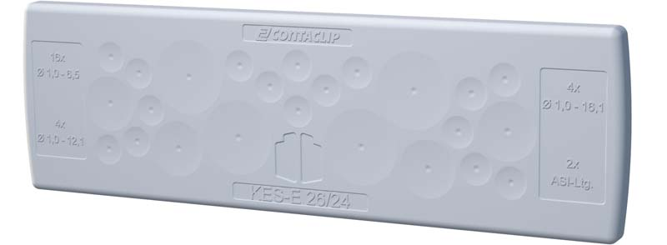
Caption: Screwless cable entry plates from CONTA-CLIP's KES-E series, which provide IP54 ingress protection for cable and conduit entries, are simply pressed into housing openings

Image/s: | KES_bsp | Characters: | 1357
File name: | 201912014_pm_kes-e_screwless_cable_entry_en | Date: | 2020-01-27
About CONTA-CLIP
CONTA-CLIP is one of Europe’s leading manufacturers of electrical and electronic connection elements and cable management solutions. Based in Hövelhof, Germany, the medium-sized, family-run company has been producing electric and electronic connection systems for the process and automation industries for 40 years. CONTA-CLIP supplies all industry sectors, focusing on railroad industries, shipbuilding, building automation, conveyor technology, machine and plant engineering and construction, instrumentation and control technology, control panel manufacturing, transformer manufacturing, and environmental technology. The company consists of many specialized branches: CONTA-CONNECT for electric connection technology, CONTA-CABLE for cable management systems, CONTA-ELECTRONICS for electronics and CONTA-CON for PCB edge connectors. Additionally, CONTA-CLIP provides services such as customizing housings and mounting rails, labeling and supplying user-specific electronic components.

Contact:  CONTA-CLIP  Verbindungstechnik GmbH  Christian Quade  Otto-Hahn-Str. 7  33161 Hövelhof  Germany  Phone: +49 . 5257 . 9833 - 0  Fax: +49 . 5257 . 9833 - 33  Email: christian.quade@conta-clip.de  Internet: www.conta-clip.com | gii die Presse-Agentur GmbH  Immanuelkirchstr. 12  10405 Berlin  Germany  Phone: +49 . 30 . 538 965 - 0  Fax: +49 . 30 . 538 965 - 29  Email: info@gii.de  Internet: www.gii.de

