Press Release

Three-level terminals with push-in connection

CONTA-CLIP expands its terminal block range featuring push-in connection for 2.5 mm² cross sections, adding the new PIKD three-level initiator terminals and multi-wire terminals. Push-in connection allows for easy, time-saving wire insertion without tools. The PIKD line is designed for 500 V rated voltage and 20 A rated current. The terminals can withstand a rated surge voltage of 6 kV. They comply with overvoltage category III and pollution degree 3. The compact terminals are 5.1 mm wide, 56.2 mm high and, depending on the model, 86 mm or 102 mm long. Their slim, tall housing geometry and wire insertion from the top enable optimized use of the available space in control cabinets. Various models cover different signal and power distribution scenarios: PE terminals, terminals with vertically connected levels for potential distribution and combined PE and feed-through terminals. Special shorter versions with a reduced number of contacts are supplied with the same height to enable uniform connection levels in cramped installation situations.

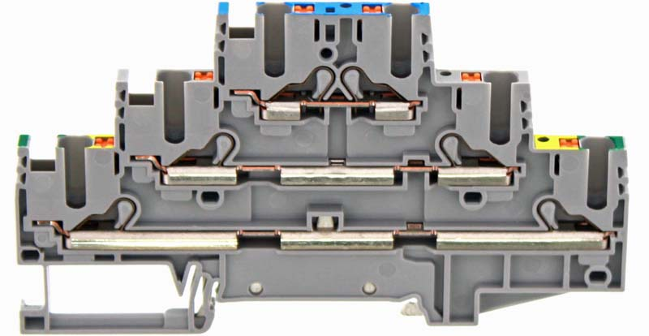
Caption: PIKD 2.5/PE/L/N GR three-level feed-through and PE terminal

Image/s: | pikd_2-5_pe_l_n_gr | Characters: | 1054
File name: | 202106020_pm_pikd_3-level_terminal_blocks_en | Date: | 06-30-2021
About CONTA-CLIP
CONTA-CLIP is one of Europe’s leading manufacturers of electrical and electronic connection elements and cable management solutions. Based in Hövelhof, Germany, the medium-sized, family-run company has been producing electric and electronic connection systems for the process and automation industries for 40 years. CONTA-CLIP supplies all industry sectors, focusing on railroad industries, shipbuilding, building automation, conveyor technology, machine and plant engineering and construction, instrumentation and control technology, control panel manufacturing, transformer manufacturing, and environmental technology. The company consists of many specialized branches: CONTA-CONNECT for electric connection technology, CONTA-CABLE for cable management systems, CONTA-ELECTRONICS for electronics and CONTA-CON for PCB edge connectors. Additionally, CONTA-CLIP provides services such as customizing housings and mounting rails, labeling and supplying user-specific electronic components.

Contact:  CONTA-CLIP  Verbindungstechnik GmbH  Christian Quade  Otto-Hahn-Str. 7  33161 Hövelhof  Germany  Phone: +49 . 5257 . 9833 - 0  Fax: +49 . 5257 . 9833 - 33  Email: christian.quade@conta-clip.de  Internet: www.conta-clip.com | gii die Presse-Agentur GmbH  Immanuelkirchstr. 12  10405 Berlin  Germany  Phone: +49 . 30 . 538 965 - 0  Fax: +49 . 30 . 538 965 - 29  Email: info@gii.de  Internet: www.gii.de

