Press Release

Ex nA motor for the oil industry on short notice

Following an urgent request for assistance, Menzel Elektromotoren has shipped one of its biggest motors yet: the squirrel-cage motor has an 800 mm frame size and a combined weight of over 33 tons including an air to air heat exchanger, external fans, and a custom terminal box. It replaces a failed compressor drive used for gas compression in an oil field. By shipping the motor within three weeks from receiving the order, Menzel ensured the continued operation of the plant, saving the customer high downtime costs. The Berlin-based company offers a unique service, standing out among other motor suppliers for its exceptionally large and diverse inventory. Menzel did not need to build the oversized motor from scratch but had it in stock, which reduced the delivery time by more than six months. The customer-focused team ensured smooth installation and reliable function of the drive, making various complex mechanical and electrical adjustments and providing expert service. Work for the high-priority project was also carried out on weekends.

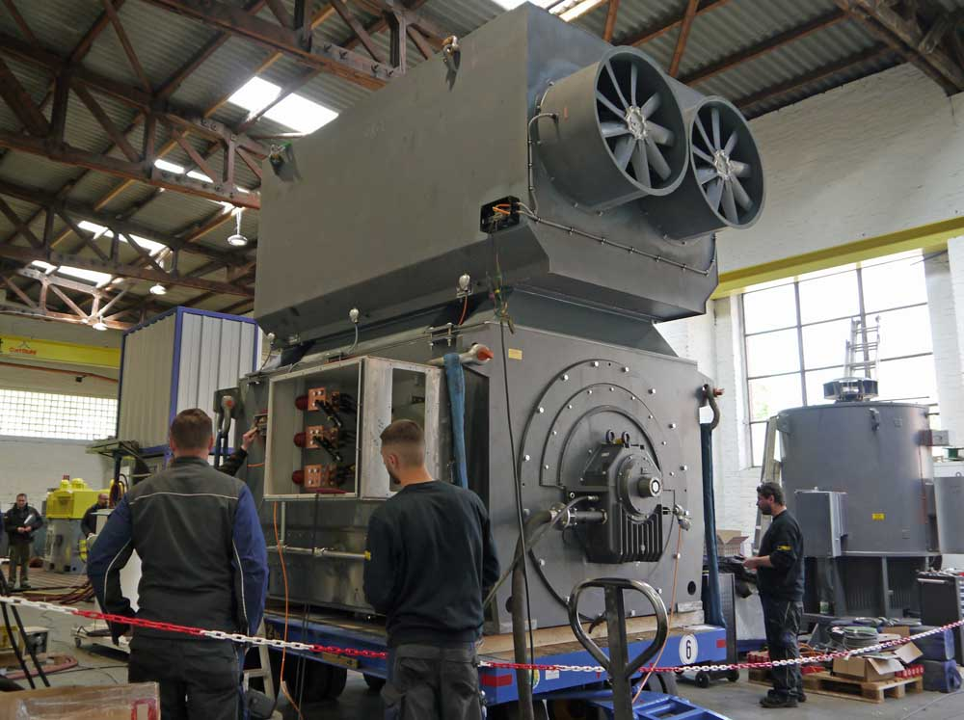
Illustration: Menzel was the only supplier able to meet the request for an XXL motor on short notice

A member of staff took the measurements on site in Algeria. The rated power of the stocked motor was adjusted from 14 MW to 7.9 MW. In adapting this existing unit for this application, Menzel welded a frame for guiding the airflow in a closed cooling circuit. The shaft was shortened, milled to the required diameter, and fitted with a new borehole. The rotor was re-balanced. The target application in the oil industry furthermore required an explosion-proof design: the adapted motor can be flushed with nitrogen before start-up. It got the Ex marking II3G Ex nA IIC T3 Gc. Menzel also integrated surge limit accessories and tested the motor with the customer present, who thus witnessed first-hand the motor's impeccable performance. Menzel supervised installation and commissioning of the motor.
Menzel presents its capabilities in customizing compressor motors on its case study web page at https://www.menzel-motors.com/compressor-drive/.

Illustrations: | compressor_motor_oil_industry | Char.s: | 1849
File name: | 201906003_pm_ex_na_compressor_motor_en | Date: | 06-12-2019
About Menzel Elektromotoren
Based in Berlin, Menzel Elektromotoren GmbH has been manufacturing and distributing electric motors for more than 90 years. The medium-sized company specializes in the delivery of large electric motors, including special models, within the shortest possible time. The product range comprises high and low voltage motors, DC motors, transformers, and frequency inverters. Services include motor production and short-term adaptation of stocked motors to application-specific requirements. In order to ensure fast deliveries to the customer at all times, the company maintains a very extensive inventory including more than 20,000 motors with a maximum performance of up to 15,000 kW. Qualified engineering, experienced staff, and state-of-the-art production and testing facilities help Menzel provide excellent reliability. Menzel operates subsidiaries in the UK, France, Italy, Spain, and Sweden, and cooperates with numerous partners worldwide.

Contact:  Menzel Elektromotoren GmbH  Mathis Menzel  Neues Ufer 19-25  10553 Berlin  Germany  Phone: +49 . 30 . 349 922 - 0  Fax: +49 . 30 . 349 922 - 999  Email: info@menzel-motors.com  Internet: www.menzel-motors.com | gii die Presse-Agentur GmbH  Immanuelkirchstr. 12  10405 Berlin  Germany  Phone: +49 . 30 . 538 965 - 0  Fax: +49 . 30 . 538 965 - 29  Email: info@gii.de  Internet: www.gii.de

