Press Release

RAFI presents first industrial touchscreen with force detection

RAFI presented its latest command and control technology innovations at the 2018 electronica exhibition in Munich, Germany. These include TWIN TOUCH touchscreen technology, new touchscreen control solutions from the FLEXSCAPE program, and the expanded line of RAMO pushbuttons. In addition, RAFI showcased new emergency stop pushbuttons for use in handheld remote control units that clearly signal their active or inactive state. As stipulated by DIN EN ISO 13850, inactive buttons do not have the appearance of safety devices.

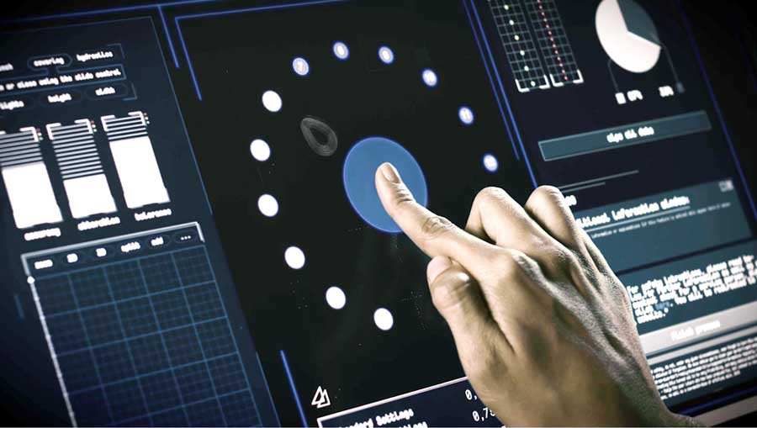
Illustration: RAFI has launched the new TWIN TOUCH capacitive touchscreen with force detection

TWIN TOUCH is a touchscreen that not only detects capacitive touch inputs but also the pressure exerted on the panel. This new feature prevents false inputs through external forces; it increases operating reliability and allows the implementation of additional input levels. Pressure thresholds for input recognition can be set via software. The new FLEXSCAPE input devices for integration in touchscreens also open up new possibilities: the FLEXSCAPE ONE pushbutton is activated by touch, but is only switched when a certain pressure threshold is exceeded. Tactile feedback to confirm switching enables safe no-look operation. A low-cost alternative to milled contours in the touchscreen, FLEXSCAPE WHEEL is a finger guide that comes as a sticker, which can simply be attached to the glass surface.
A selection from RAFI's vast portfolio of switches was also on display, notably including new products from the RAMO series with M12 connectors: emergency stop pushbuttons, selector switches, key switches, and USB/RJ45 bushings now complement the existing range of pushbuttons and signal lamps in the RAMO lineup. Featuring single-part, fully enclosed IP65-rated mono-housings, these control elements and lamps are fully protected against spray water. They can be easily installed without additional protective enclosures and enable plug & play connection via M12 plugs. Thus, they provide an extremely economical and practical solution for fitting distributed industrial applications with individual operating and display elements. RAFI furthermore presented the new LUMOTAST 16 active/inactive emergency stop pushbutton for detachable or wireless control units. Only when the control device is actively connected, this pushbutton made of transparent colorless plastic is lit up by a red LED, as required by DIN EN ISO 13850. On inactive buttons, the light is off. Lacking the typical red coloring, the clear plastic mushroom cannot be easily mistaken for a functional E-Stop control.
Visit RAFI at the 2018 electronica exhibition: Hall A2, Stand 101

Illustrations: | TwinTouch | Char.s: | 2511
File name: | 201811003_pm_electronica_en | Date: | 11-14-2018
Company background RAFI group
Founded in 1900, RAFI now develops and produces electromechanical components such as pushbuttons and switches, operating systems such as touch screens, keyboards, electronic components, and systems for man-machine communication. RAFI products are employed in more than 30 industries, e.g., in medical equipment, mechanical engineering, road and railway vehicles, household appliances, and telecommunications. The RAFI group operates internationally with approx. 2,500 employees at ten sites in Germany, Europe, China, and the USA. The group’s headquarters are located in Berg (Baden-Württemberg, Germany).

Contact:  RAFI GmbH & Co. KG  Artur Krug  Ravensburger Str. 128-134  88276 Berg  Germany  Tel.: +49 . 751 . 891 307  Fax: +49 . 751 . 891 300  e-mail: artur.krug@rafi.de  WWW: www.rafi.de |  | gii die Presse-Agentur GmbH  Immanuelkirchstr. 12  10405 Berlin  Germany  Tel.: +49 . 30 . 5389 650  Fax: +49 . 30 . 5389 6529  email: info@gii.de  Internet: www.gii.de

