Press Release

MIPI camera giveaway

Vision Components announces a special offer for students: high-end MIPI camera modules for €39.99 net. What is more, the first 100 students to order the VC MIPI Students’ Package get it for free. The deal includes a VC MIPI OV9281 camera module with a 1MP OmniVision sensor, a trigger input, a flash trigger output, a lens holder, and a robust driver for optimal communication between the sensor and the CPU board. The camera supports the MIPI CSI-2 specification. It connects to a Raspberry Pi via a flex cable, which is also part of the package. VC MIPI camera modules in general are compatible with over 20 CPU boards, users are free to choose. The OV9281 global shutter sensor has a 1280 x 800 px resolution and supports clock rates up to 120 fps. Contact details and further information on this promo campaign is provided at https://www.vision-components.com/en/students-offer/.

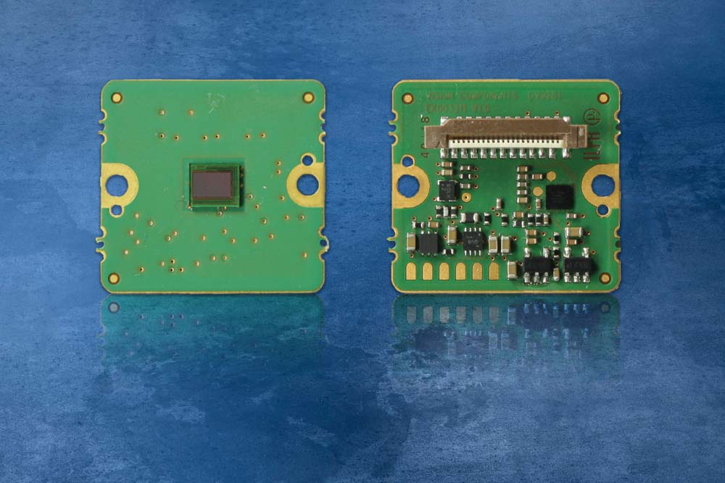
Illustration: The first 100 takers get a VC MIPI Student Package from Vision Components for free

Vision Components is the technology leader in manufacturing industrial MIPI camera modules, ready to ship the largest range of sensor boards with resolutions up to 13MP. VC MIPI camera boards are 100% developed and manufactured in Germany. They are used in applications such as autonomous driving, AGVs, UAVs, and smart city services. This new product line complements the manufacturer's range of embedded vision systems.

Illustrations: | vc_mipi_ov9281 | Char.s: | 1304
File name: | 201906018_pm_mipi_students_package_en | Date: | 06-19-2019
About Vision Components
Vision Components is a leading international manufacturer of embedded vision systems. The freely programmable cameras with powerful onboard CPUs perform image processing tasks on their own without the need for an additional computer. Vision Components offers OEMs versatile Linux-based embedded systems for 2D and 3D image processing, supplied as board cameras or in protective casings. These are complemented by a growing range of ultracompact MIPI camera boards, which connect to a variety of different CPU boards. In addition, Vision Components offers software libraries and develops customized solutions on request. The team of experts can draw on extensive knowledge and over 20 years of experience with imaging applications. The company based in Ettlingen in southwestern Germany was founded in 1996 by Michael Engel, the inventor of the first industrial-grade intelligent camera. More world premieres followed, including the world's first intelligent vision sensors and the first-ever embedded 3D laser profiler. Today, Vision Components has sales offices in the United States and Japan and works with local partners in over 25 countries to provide consistent customer focus and readily available expertise throughout the world.

Contact:  Vision Components GmbH  Miriam Schreiber  Ottostr. 2  76275 Ettlingen  Germany  Phone: +49 . 7243 . 216 716  Email: miriam.schreiber@vision-components.com  Internet: www.vision-components.com | gii die Presse-Agentur GmbH  Immanuelkirchstr. 12  10405 Berlin  Germany  Phone: +49 . 30 . 538 9650  Email: info@gii.de  Internet: www.gii.de

